UNIT 5
MULTIMEDIA CONTENT: TYPES AND TECHNOLOGIES
Content  - multimedia terms and features;  - multimedia formats and components;  - multimedia messages;  Language  - basis terms and vocabulary related to the multimedia content;  - discussing the content, type and technologies used in multimedia messages;  - developing writing skills to create multimedia projects;  - presenting multimedia projects;  Critical thinking  - interpreting visuals and data;  - analyzing the patterns of clickbait and speculative news | 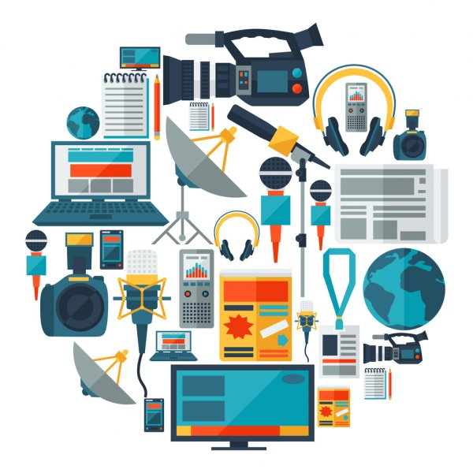

PRE-LECTURING:
- What is Multimedia & Definition of Multimedia (2018) 2.30 min https://www.youtube.com/watch?v=Fg06vz1Krcc&ab_channel=SimplyInfo
or
Multimedia Contents (2020) 8 min
https://www.youtube.com/watch?v=dWf5LT6ARRQ&t=19s&ab_channel=SimplyInfoSimplyInfo

PART 1. ACTIVATING PRIOR KNOWLEDGE

Ex.1. Look at the visuals
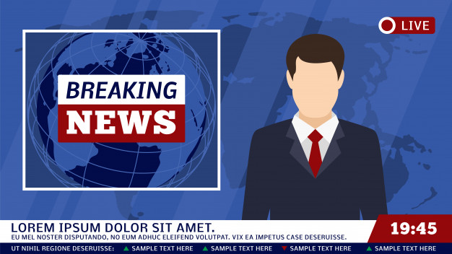
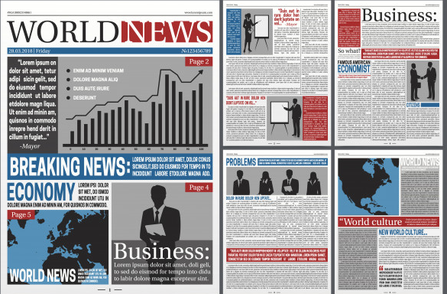

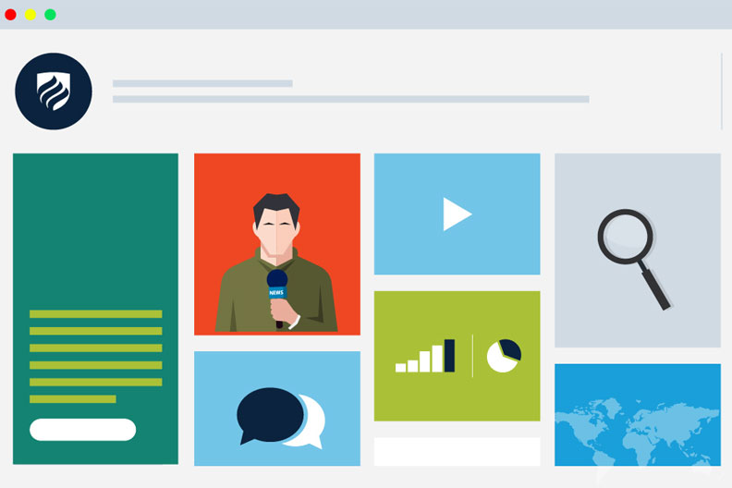

Answer the questions:
- What media do you see?
- What types of content do you identify?
- What kind of content can combine in newspapers, radio, tv, digital media?
- What kind of content do you prefer more than others in your everyday mediaactivity? Why?

Ex.2. Select characteristics of different media
 | Text | Sound | Picture | Video | Live | Interactive*
Print | yes | no | yes | no | no | no
Radio | no** | yes | no | no | yes | no***
Film
Television
Internet

*We are using “interactive” here to mean a medium that enables easy, two-way communication between producer and user.
**Although digital radio, film, television (video), and sound recordings can show text on a screen, they are not primarily textual media.
***Two-way communication is possible using radio technology, but most modern radio sets do not allow for this

Ex.3. Watch the video “Text vs. Visuals: Which Content Format is Effective?”
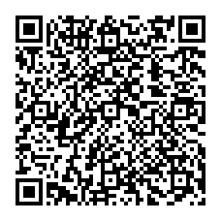

Decide if the next statements are true or false.
1. | The human brain can process entire images that the eye sees for as little as 13 milliseconds | true or false
2. | When an image is seen for only 13 milliseconds before the next image appears, a part of the brain continues to process the images longer than the amount of time it was seen | true or false
3. | People following directions with text and illustrations do 323 percent better than those following directions without illustrations. | true or false
4. | When people hear information, they’re likely to remember more than 65 percent of that information three days later. On the other hand, if a relevant image is paired with that same information, people retained 10 percent of the information three days later. | true or false
5. | Your brain learns new words by adding these words to your brain’s “visual dictionary” | true or false
6. | Tweets without images receive 150 percent more retweets than tweets with images | true or false
7. | Using visuals with text makes more sense if you’re looking to communicate with impact and make your content more memorable. | true or false
Ex. 4. Reconstruct the text. Discuss how you can prove or disprove these claims.

But they tell their stories through some combination of text, images, sound, video and graphics. Increasingly affordable and accessible technology has only added momentum to the trend. Multimedia journalism is a relatively new—and still developing—career path. Multimedia journalists are storytellers who work across many dimensions. It grew out of a mushrooming of digital platforms and social media channels, and a shift in people’s preference for how they consume the news. Journalism has been around for centuries. They embrace the traditional tenets of journalism: objectivity, accuracy, credible sourcing and strong writing.

PART 2. PROVIDING AND ENCOURAGING OUTPUT

Ex. 5. Look at the infographic (https://devrix.com/wp-content/uploads/2016/10/Multimedia-Infographic.png)
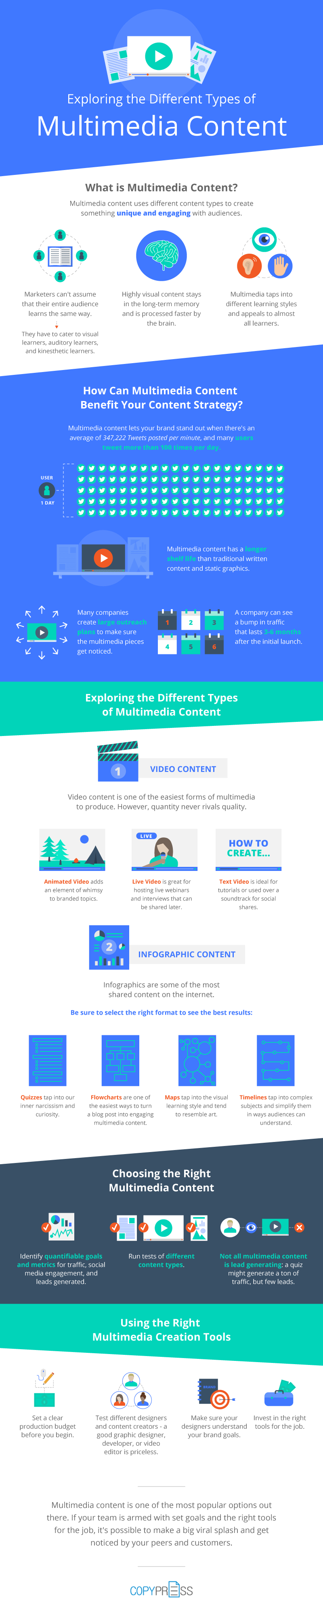

Answer the following questions:
- What is the purpose of multimedia content in advertising?
- Why do marketers consider multimedia content effective?
- How do you understand the property of multimedia content "engaging"?
- What are the most popular and most effective types of content in advertising?
- Which video content do you consider the most popular?
- Do marketers use users to produce video content? For what purpose?
- Why is infographics the most shared type of multimedia content?
- Why do users actively interact with quizzes? Do you take quizzes online? For what purpose?
- What manipulative techniques are used in the quizzes?
- How to properly interact with advertising multimedia content to avoid falling into manipulative traps?

Ex 6. Scan the multimedia stories. Identify different types of content, analyze their functions and impact. Fill out the table.

NTR & Rijksmuseum – Experience the Night Watch


Pointer – The story behind an identity theft
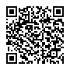
The Guardian - Firestorm
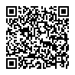
Content | Function | Impact
Sound | presence effect | immersive experience
Voice
Music
Text
Video
Photo
Collage
Animation
Infographic
….

PART 3. READING

Ex. 7. Before reading the text, scroll your social media. What kinds of multimedia formats do you find? Explain why some of them are more popular than others? What kind of social content do you like to create? What kind of apps do you use to create social content?

Ex. 8. Look at this infographic. Do you use these apps? What kinds of apps do you use to create social content?
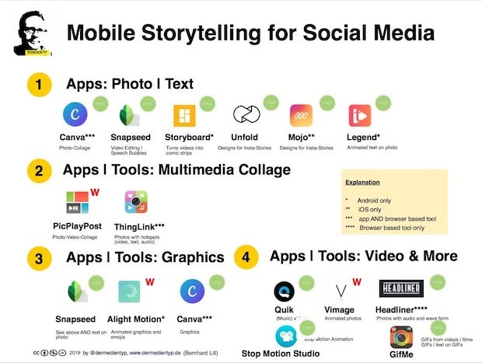

Ex. 9. Read the text

The Rise of Mobile Journalism: Publishing’s New Frontier?
(Adopted from WINP)
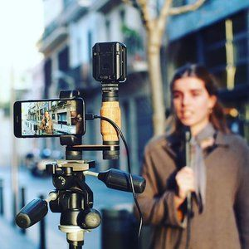
Ever since the pivot to online publishing, journalism has been adapting its traditional methods of newsgathering and publishing to suit the digital era. The rapid evolution of technology and the consequent shift to online publishing has led to a rise of mobile journalism.
From publishing political new stories to covering village fairs, mobile journalism, otherwise known as ‘mojo’, is quickly becoming an essential tool for publishers. But what is mobile journalism?
Mobile journalism is a new workflow for digital storytelling where reporters are trained and equipped for being fully mobile and fully autonomous. A modern-day mobile device can be used for storytelling, as most phones have the ability to shoot, edit, and broadcast on a single device.
Even the BBC has developed its own app called Portable News Gathering (PNG) which can record, edit and send videos, audio, and photos straight into the newsroom production systems. Speaking to Shoulderpod, Marc Settle, a BBC trainer commented on the rise of mobile journalism, saying:
“Mobile journalism is the biggest revolution in news in decades and it’s time everyone jumped on board”.
Being the first to broadcast is essential to publishers, as they try to beat competitors to distribute the latest news and information. An advantage of mobile journalism is that it allows publishers to publish instantly. The easy accessibility of being able to shoot, edit and broadcast all in the one place removes the amount of time needed to distribute footage, speeding up the publication process.
It is also cost-effective for a publisher as set-up costs are far less than an entry-level TV camera, and makes multimedia storytelling affordable for publishers around the world. According to Torben Stephan, publisher of the Mobile Journalism Manual, mojo is becoming increasingly popular because it is so cheap.
With only a US$200 phone and a US$30 tripod and microphone kit, publishers can produce content easily. Mobile reporting is also portable, as most mobile journalists can fit their equipment in a backpack. The phone plus a lightweight tripod, clip-microphones and an external light can weigh under 3kg, making it easy to produce high-quality stories anywhere, anytime
Although mobile may seem daunting at first to publishers, the KAS Media Programme and a team of multimedia journalists led by Corinne Podger have recently launched an online manual focused on teaching publishers and newsrooms to produce quality reports using just their phones.
“The challenge was sharing the knowledge about mobile journalism with journalists that are ready to report and publish about local contexts,” said Stephan. The manual created by the team is free and open-sourced. The original version is in English, but the team is open to developing the manual for international publishers.
Accessible for all, for better or worse
The wide accessibility of mobile devices today means that it’s not just reputable publishers that can use mobile journalism as an effective tool for publishing. Citizen journalism is the collecting and reporting of information via social media or public platforms by members of the public. The rise of citizen journalism is a direct result of the evolution of technologies and the easy accessibility to publishing on social media platforms.
With the power of social media, citizen journalism has the potential to be a threat to traditional publishers, as news produced by them is likely to spread faster. The content produced can also be unprofessional which can taint the reputation of reputable publishers. However, whenever an industry is undergoing change, growth pangs are always there, before what’s new is assimilated and becomes the new normal.
Current affairs are benefiting from citizen journalism and video testimony from ordinary citizens. Speaking to the Guardian, Chris Shaw, editorial director of ITN productions said, “Social networks are opening up whole new vistas for documentary filmmakers, and publishers can make the most amazing films using content from social networks.”
Despite the wide accessibility that mobile journalism enables, publishers can benefit from its instant publishing capabilities and low running costs.
Answer the following questions:
- What is mobile journalism?
- What makes mobile journalism unique?
- What mediaskills can you develop using your smartphone?
- How can you use your smartphone for digital storytelling?
- What ground-breaking projects can journalist create using smartphone?
- What is citizen journalism?
- Why does citizen journalism have the potential to be a threat to traditional publishers?
- When you create social content, do you feel more like a citizen journalist or mobile journalist?

PART 4. GUIDING TO MORE CALP

Ex 10. Read the text. Transform the text into the infographic. Use free infographic makers (look for the list of free infographic makers after the text)

Social media - Statistics & Facts

(from Statista)
One of the defining phenomena of the present times reshaping the world as we know it, is the worldwide accessibility to the internet. The lovechild of the World Wide Web is social media, which comes in many forms, including blogs, forums, business networks, photo-sharing platforms, social gaming, microblogs, chat apps, and last but not least social networks. In 2020, the global social penetration rate reached 49 percent, with East Asia and North America having the highest penetration rate at 71 and 69 percent respectively, followed by Northern Europe at 67 percent.
The power of social networking is such that the number of worldwide users is expected to reach some 3.43 billion monthly active social media users by 2023, around a third of Earth’s entire population. In 2023, an estimated 800 million of these users are expected to be from China alone and approximately a 450 million from India.
Leading social networks usually boast a high number of user accounts or strong user engagement metrics. For example, Facebook is the first social network having surpassed the 1 billion monthly active user mark and as of the first quarter of 2020, has 2.6 billion MAU worldwide. The platform is also ranked first among the most popular social networks worldwide. Other leading social apps and networks include photo- and video sharing platform Instagram, which has over 1 billion monthly active users and most recently reported 500 million daily active users for its Stories feature. Messaging apps including WhatsApp, Facebook Messenger, and WeChat are also popular social channels for online users.
Despite the ubiquity of social networks market potential is still increasing, as not only user figures but also user engagement continues to grow. On average, global internet users spend some 144 minutes per day surfing social networks. This prompts worldwide brands and their marketers to use that time and screen space to promote various products and services via social media marketing or social advertising.
In recent years, social networking has demonstrated a clear shift towards mobile platforms. Smartphone and tablet apps as well as mobile web access have facilitated the constant presence of mobile-first or mobile-only platforms such as Twitter, Instagram, or Snapchat. In addition, these kinds of applications have heightened the profile of location-based services like Foursquare and enabled users to comfortably access visual blogging sites including Tumblr and Pinterest via tablet. As of 2018, 99.2 million online users in the United States accessed social networking sites exclusively via mobile devices.
The Statista Global Consumer Survey offers additional comprehensive information on social media usage in the United States, including data on frequency of social networking, popularity of selected social platforms among internet users as well as common activities performed on those platforms. With the option to display results broken down by desired target group, Statista’s Global Consumer Survey provides insights into the habits of social media and instant messaging users.

Before making the infographics, watch the videos.
7 Common Types of Infographics | What Makes an Effective Infographic? | How to Write Content for Your Infographics
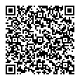 |  | 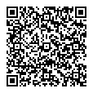

List of free infographic makers
- Easel.ly https://www.easel.ly/
- Canva - https://www.canva.com/
- Piktochart - https://piktochart.com/
- Infogr.am - https://infogram.com/
- Visual.ly - https://visual.ly/
- Draw.io - https://app.diagrams.net/

Ex. 11. Read the text. Pick different visual contents (images, photo, gif etc), using free photo stocks and photo banks

5 Graphic Design Trends for 2021 and 2022
2020 has been a rough year with not too many brands taking design risks. Even now, in 2021, times are unpredictable. What I think will happen for 2021 (and probably 2022) is that many trends will be a consequence of the last year events – attention to everything is related to medicine and healthy or data visualisation. Some trends will merely continue what was successful in 2020 (flat icons, illustrations and motion).
Design is the way to engage with the world around us, and how things are presented online or in print, where our daily lives have never been so important. It is not surprising then that a calm and relaxing mood pervades our trend forecasts with new colours palette, geometric shapes, tranquil graphics, optical illusions, and fantasy 3D illustrations. Alongside this, it runs a thread of trends that are reactionary to 2020 with clean info-graphics, simplified medical branding and activist-influenced design aiming to address the problems that a pandemic year has brought. Read on to discover our trend prediction for design and get ahead of the curve in your projects.
1- Calm and tranquility
After a tumultuous year for the design community and the world as a whole, it’s time to breathe, reflect and look forward. Soothing, 2021’s design mood will be a salve to the upheaval of 2020. Calming colours with a nice palette from blue and violet to green and tan, meditative graphics and minimal layouts are welcome responses to the pandemic effects and the daily saturation of online news and information.
2- Contemporary medical branding
One of the more popular trends due to COVID crisis has seen many designers turning their attention to the design of medical packaging and health and medicine brands. With many of us spending more time at home, there is an increasing focus on self-care and wellness. Everything related to these is getting simple and refreshed, with instantly recognisable graphics, creative colour and vibrant makeover. By looking more contemporary, many of these designs play a fundamental role in the user experience side, allow users to locate the right medicine quickly, or raise and promote health awareness through graphics and drawings.
3 – Simple info-graphics and illustrations
Today need and trend in editorial design and social images are to stripped-back simple info-graphics and illustrations that seek to explain complex topics more concisely. Due to the pandemic, there are tons of data and information flying around in all parts of our lives. As a designer or communicator, you should be making that data less scary but easy to comprehend. An interesting inherited trend is the use of “slide decks” in platforms such as LinkedIn and Instagram, a simple way to have hands-on information, receive help for a product or even repurpose popular contents from a blog post. These slide decks get about 10-20x more impressions and clicks than a simple visual or graphic. Remember: a keyword for 2021 is simplicity even with a touch of optical illusions and vintage style.
4 – Motion
Static designs are almost over. You can expect more demand from clients to modernise their brand with a bit of locomotion (or “logomotion” as it were). With an increasing number of traditional companies moving into the digital/social media space, there will be a need to captivate and engage in new ways. Motion is perfect and is also an excellent visual storytelling tool, used more and more often. With motion design, you can engage viewers and communicate ideas in a brisk captivating manner.
5 – Geometric Shapes
As a top keyword of 2021, Simplicity clears up the geometric shapes and patterns will appear on illustrations and layout. These shapes can be regular and clean or be mixed with psychedelic elements, trippy design and mid-century style. These to give consistency, tidiness and structure to your visual or even texture and depth to your graphic.

List of free photo stocks and photo banks
- Pixabay - https://pixabay.com/
- Life of pix - https://www.lifeofpix.com/
- Pexels - https://www.pexels.com/uk-ua/
- PicJumbo - https://picjumbo.com/
PART 5. WRITING

Ex 12. Look at the infographic. Create the headline and write the lead (200-300 symbols)
The lead is the introductory paragraph of the newspaper article. It provides an overview or the main idea of the news article. It generally describes 'who', 'what', 'when' and 'where'. It is written in such a way that it encourages a reader to want to find out more information.

Structure of News Reports
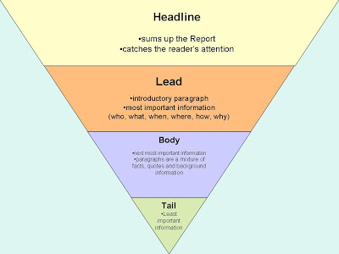

The infographics for exercise
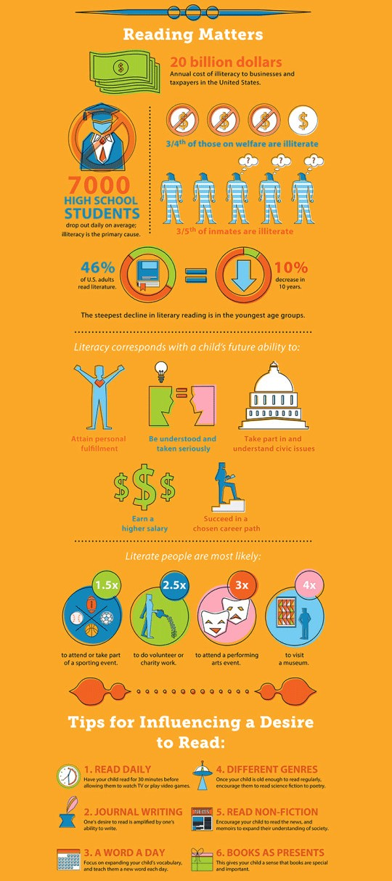
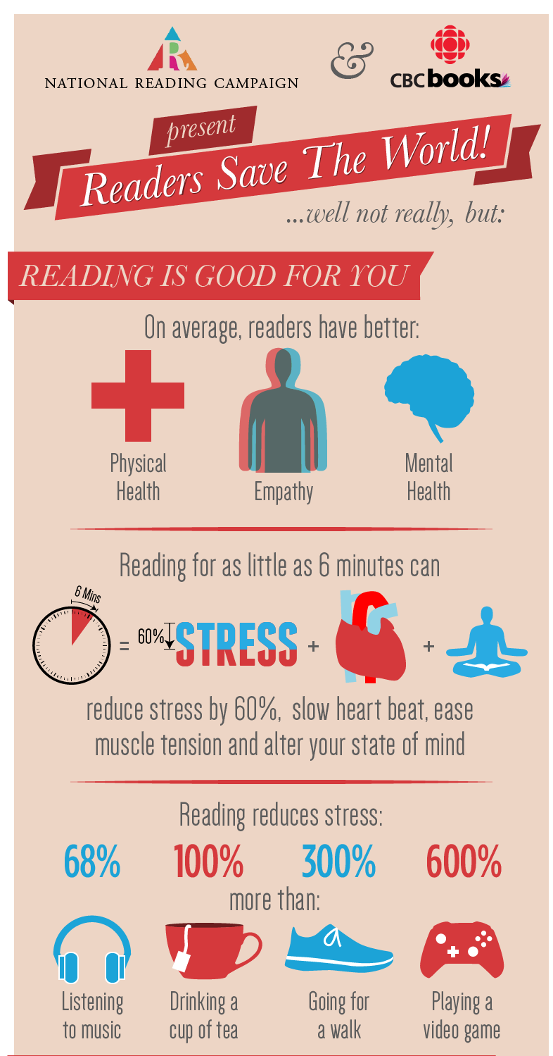

Ex 13. Look at the photoset. Create the photo story (reportage):
- Write the headline
- Write the lead
- Write the captions under the photos













PART 6. FURTHER EDUCATIONAL RESOURCES

Ex. 14. Check if you remember the terms and expressions from this unit.
Animation, audio slideshow, caption, citizen journalism, collage, headline, infographic, interactive, lead, mobile journalism, multimedia contents, multimedia journalism, multimedia.
Ex. 15. Read the texts

Whatever happened to the audio slideshow?

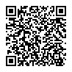
What makes a good audio slideshow: the dos and don’ts
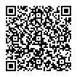
Analyze the following slideshow examples according to the rules in previous text

Kingsley’s Crossing King’s Daughters: Tools for a New Life
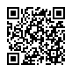


Home assignment
In pairs create an audio slideshow about your hobbies (2 projects). Do it following this algorithm:
- Prepare a script of your story (activate prior knowledge about storytelling and narrative)
- Write the text. Record the voice on smartphone (dictaphone). You can edit sound using free audio editor Audacity (https://www.audacityteam.org/)
- Take photos / videos.
- According to the script, decide where in your multimedia story you have to use photos with voice, photo with sounds or music, video with voice/sound/music, slides with texts.
- The first slide is the title of your audio slideshow. Create an accurate, lifelike, authentic, exclusive, tolerant title.
- Arrange all materials using free slideshow makers for browser or smartphone:
Canva - https://www.canva.com/
Animoto - https://animoto.com/k/video-slideshow
Adobe Spark - https://www.adobe.com/express/
Movavi - https://www.movavi.com/slideshow-maker-for-mac/
Slide.ly - http://slide.ly/#show-screen
- Save the audio slideshow and bring it to the next lesson. Prepare to present your project.

PART 7. REFLECTION

Answer the questions:
- What do I want to learn? What is my learning objective in this seminar?
- What did I learn in this seminar? What was new information to me?
- What am I planning to do with the new knowledge I have attained during the seminar? How will I implement it in my work right now and in the future? Is it relevant to my field of studies?
- How will I continue learning on the topic of multimedia after the seminar?

References:
- What is Multimedia & Definition of Multimedia - https://www.youtube.com/watch?v=Fg06vz1Krcc&ab_channel=SimplyInfo
- Multimedia Contents - https://www.youtube.com/watch?v=dWf5LT6ARRQ&t=19s&ab_channel=SimplyInfoSimplyInfo
- Text vs. Visuals: Which Content Format is Effective? – https://www.youtube.com/watch?v=YOuOuIJR0Dw&t=4s
- NTR & Rijksmuseum – Experience the Night Watch – https://beleefdenachtwacht.nl/en
- Pointer – The story behind an identity theft – https://pointer.kro-ncrv.nl/het-verhaal-achter-een-identiteitsroof#lang=en
- The Guardian - Firestorm – https://www.theguardian.com/world/interactive/2013/may/26/firestorm-bushfire-dunalley-holmes-family
- The Rise of Mobile Journalism: Publishing’s New Frontier? – https://whatsnewinpublishing.com/the-rise-of-mobile-journalism-publishings-new-frontier/
- Social media - Statistics & Facts – https://www.statista.com/topics/1164/social-networks/
- What Makes an Effective Infographic? – https://www.youtube.com/watch?v=rl9ZcfKt8sY&ab_channel=Easelly%3AInfographicDesignTips%26Tutorials
- 7 Common Types of Infographics - https://www.youtube.com/watch?v=A6_7zC0mB9w&t=72s&ab_channel=Easelly%3AInfographicDesignTips%26TutorialsEaselly%3AInfographicDesignTips%26Tutorials
- How to Write Content for Your Infographics - https://www.youtube.com/watch?v=cK0pfcsfGj0&ab_channel=Easelly%3AInfographicDesignTips%26TutorialsEaselly%3AInfographicDesignTips%26Tutorials
- 5 Graphic Design Trends for 2021 and 2022 - https://www.comdart.it/5-graphic-design-trends-for-2021-and-2022/
- Whatever happened to the audio slideshow? - https://onlinejournalismblog.com/2016/12/13/whatever-happened-to-the-audio-slideshow/
- What makes a good audio slideshow: the dos and don’ts - https://themultimediajournalist.wordpress.com/2013/03/15/what-makes-a-good-audio-slideshow-the-dos-and-donts/

Further readings:
- Apps for mobile photography, video, and social media - https://www.mojo-manual.org/mojo-manual-apps/
- Exploring the Different Types of Multimedia Content - https://www.copypress.com/marketing-resources/whitepapers/Exploring-Different-Types-Multimedia-Content.pdf
- Multimedia Content definition- https://www.openpr.com/wiki/multimedia-content
- Smartphones vs traditional news equipment - https://www.mojo-manual.org/managing-smartphone-limitations/
- The benefits of mobile journalism - https://www.mojo-manual.org/benefits-of-mobile-journalism/
- Tutorial: Multimedia Storytelling: learn the secrets from experts - https://multimedia.journalism.berkeley.edu/tutorials/starttofinish/
- What is mobile journalism? - https://www.mojo-manual.org/understanding-mobile-journalism/
Glossary:
Animation - animation moviemaking technique of showing slightly different drawings in rapid succession, creating the illusion of continuous motion (this visual illusion is also illustrated by “flip books”)
Audio slideshow - a form of storytelling commonly found in digital journalism. They combine images and sound (narration, natural sounds, music) to create engaging stories.
Caption - 1. tagline for an advertisement; 2. verbal text accompanying an illustration or photograph; 3. short on-screen text that explains or relates to the visual image (for example, the name of the person who is talking)
Citizen journalism - [also called civic journalism] practice centered on the participation of readers and journalists in community issues, making newspapers a forum for discussion and engagement
Collage - a work of art created by cutting, arranging, and adhering various materials, such as cloth, paper, photos, and other objects, onto a surface
Headline - 1. short title printed in heavier type at the top of a newspaper article telling what it is about; 2. line printed at the top of a page giving the running title, page number, and possibly
Infographic - graphic visual representations of information, data, or knowledge intended to present information quickly and clearly
Interactive media - media that allow for two-way communication between the media and users (such as viewers), enabling users to obtain responses in real time,
Lead - - the introductory paragraph of the newspaper article. It provides an overview or the main idea of the news article. It generally describes 'who', 'what', 'when' and 'where'. It is written in such a way that it encourages a reader to want to find out more information.
Mobile journalism (mojo) - an emerging form of new media storytelling where reporters use portable electronic devices with network connectivity to gather, edit and distribute news from his or her community
Multimedia content - a mean to distribute and represent digital information by combining text, pictures, sound and video.
Multimedia journalism - the practice of contemporary journalism that distributes news content either using two or more media formats via the Internet, or disseminating news report via multiple media platforms.
Multimedia - computer system that allows the user to manipulate and use different types of media, such as text, sound, video, graphics, and animation. The most common multimedia system consists of a personal computer with a sound card, modem, digital speaker unit and portals for various devices.

Summative Assessment

- Which is an example of interactive media?
- A newspaper
- Traditional Radio
- A magazine
- Internet

- Who can tell stories through the combination of texts, images, sounds, videos, and graphics?

- Multimedia journalists
- Print journalists
- Radio journalists
- Citizen journalists

- What is a practice that centres on the participation of readers and journalists in community issues, making newspapers a forum for discussion and engagement?

- Multimedia journalism
- Citizen journalists
- Television
- Mobile journalism

- What is the visual representations of information, data, or knowledge intended to present information quickly and clearly

- Infographic
- Collage
- Multimedia
- Photo

- What kind of impact does music content have in multimedia projects?

- Immersive experience
- Objectivity
- Visual experience
- Interactive experience

