UNIT 8
FACT-CHECKING AND DEBUNKING MYTHS
Content  - features of information reliability.  - the main sources of false information.  - verification and fact-checking of information messages  Language  - basic terms and notions of fact-checking;  - improving reading and speaking skills;  - improving their presentation skills.  Critical thinking  - analyzing the sources of fakes in media;  - personalizing experience on informational issues;  - reflecting the personal progress. | 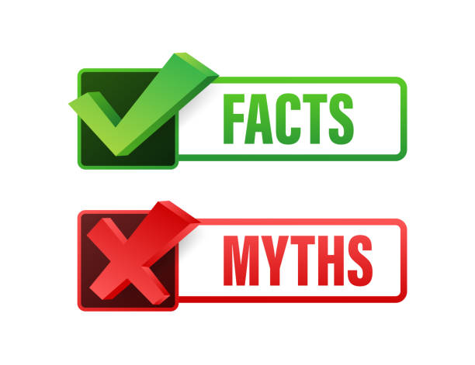

PRE-LECTURING:
- Fact checking online is more important than ever - https://www.youtube.com/watch?v=Ryjpu-NWYm8&t=54s
- Olga Yurkova: Inside the fight against Russia's fake news empire - https://www.ted.com/talks/olga_yurkova_inside_the_fight_against_russia_s_fake_news_empire
- Linda Beck: Fact Checking in a Fast-Paced Social Media Driven World - https://www.ted.com/talks/linda_beck_fact_checking_in_a_fast_paced_social_media_driven_world

PART 1. ACTIVATING PRIOR KNOWLEDGE

Ex. 1. Test your fact-checking skills
Quiz “Break-fake-news”
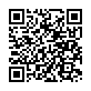

Answer the questions:
1. How do you distinguish between true and fake news? What rules do you follow?
2. Do you share the news that excited you on social media? Why?
3. Do you comment on / criticize posts with false news?
4. What news sources do you use?
5. Who or what influences the choice of sources of information?

Ex.2. Read the quotations about critical thinking. Do you agree with them? Why? Why not?
The important thing is not to stop questioning. Curiosity has its own reason for existing. (Albert Einstein, winner of the Nobel Prize in Physics)
It is the mark of an educated mind to be able to entertain a thought without accepting it. (Aristotle (Greek philosopher)
Read not to contradict and confute; nor to believe and take for granted; nor to find talk and discourse; but to weigh and consider. (Francis Bacon, English essayist)

PART 2. PROVIDING AND ENCOURAGING OUTPUT

Ex. 3. Watch the video “Five ways to spot fake news”
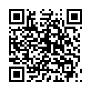
Answer the questions:

1. What are the five main elements a teacher calls for checking fake news?
2. How do you understand the phrase "We all need to become digital detectives"?
3. What characteristics of a quality news site can you name?
4. What is a quality title?
5. Why is the emotional neutrality of the title important?
6. Why is it necessary to identify the author of the publication?
7. In which cases can publications be without authorship?
8. Are references to sources in the article important? Why?
9. How can I verify the authenticity of the image?
10. How can an image or photo distort the authenticity of text support?

Ex 4. Read this article
Футболіст, що забив два голи збірній Росії, отримає квартиру від Зеленського

Using the recommendations of the previous task, analyze the publication. Determine if it is true or fake. What analysis algorithm did you use?

Ex. 5. Before reading the next article, watch the video “The CRAP Test for Evaluating Websites”.
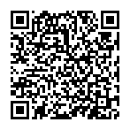
Make a visual summary of CRAP Test
Hand-made or using list of free infographic makers
- Easel.ly https://www.easel.ly/
- Canva - https://www.canva.com/
- Piktochart - https://piktochart.com/
- Infogr.am - https://infogram.com/
- Visual.ly - https://visual.ly/
- Draw.io - https://app.diagrams.net/

Ex. 6. Read the article “If women in Ukraine love working in tech, why are there so few?”
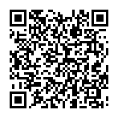
Evaluate the article using the following criteria.
Currency:
When was this article written/updated? | Date:

Relevance:
Is the article’s information still relevant today?

Who is the intended audience of this article?
Are there links to other sites within the article? If so, how many?

Authority:
Who authored this article? Is it a person or institution?
What are the website’s/publication’s credentials? How do you know this author is an expert?

Look up the author/institution in Google. What do others say about him/her/it?

What is the site’s bias?*
According to Merriam-Webster, bias is defined as “prejudice in favor of or against one thing, person, or group compared with another.”

Purpose:
Why was this article published? Is it intended to persuade or inform?
Who is the intended audience? The general public? Scholars? First-year students like you? All of the above?

Are there advertisements or other types of content attached to the site where the article is published? If so, what purpose do they serve?

Adapted from Keene Info Lit Bank’s CRAP worksheet: http://kscinfolit.wordpress.com/2011/07/12/c-r-a-p-test-map-worksheet-and-handout/.

PART 3. READING

Ex. 7. Before reading the text, answer the questions:

How do you understand the notion of “myth”?

What kind of function do they have in information space?

Why is it necessary to debunk myths?

What myths have you had to deal with?

How did you manage to debunk them?
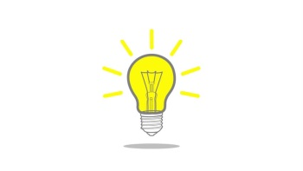  To check your knowledge go to Macmillan Dictionary. Find meanings of word “myth”  How is the word “myth" related to the words “fact”, “media”? Which synonyms and related words do “myth” has? | 

FACT VS MYTH
(Adopted from Difference Between)
The basic difference between fact and myth is the ability to gather scientific evidence to support a fact. For instance, we say smoking causes lung cancer. Until the medical science community was able to document and scientifically prove, beyond a doubt, that smoking cigarettes directly contributes to lung cancer, it was considered a myth.
The origin between fact and myth can also be considered a difference. Myths are often derived through word of mouth, or the reliance on being passed down from generation to generation. For instance, it has been said that eating hot pepper will help cure the flu. This has been traditionally handed down from one generation to the next, without any scientific back-up.
Myths commonly start, or are passed on, through the form of a story. The most glaring example of this is Greek or Roman mythology. The stories that were translated during these times were done so in order to help explain something that could not, at that point, be explained through scientific reasoning.
This brings us to the reason for their development. Myths are generally started to explain away something, or to give a sense of understanding or control over something. Whether you’re talking about an angry Zeus to explain a typhoon, or you’re speaking of a hot pepper remedy for the flu, there is an air of human contribution. We all want to be able to feel we understand and control our environment, at least on a personal level. Facts are derived, often by accident, by simply gathering evidence to explain something. There is not supposed to be an air of human quality. The disassociation from the answer, makes it all the more objective, provable, and reliable.
Just because something is considered a myth, does not make it false. Generally, a myth cannot be disproved, just as it cannot be proven. To some, the concept of heaven is a myth, simply because proving or disproving its existence is rather impossible in this life. On the other hand, a false fact can be disproven. When people believed that the world was flat, they took it as fact. By being able to disprove the fact, the opposite actually became the new fact.

Fill the table about differences between fact and myth

FACT | MYTH
based on the ability to gather scientific evidence as proof of the statement. | originate from generational thoughts and beliefs, while facts are given as evidence.

Ex. 9. Read the text

HOW TO DEBUNK FALSEHOODS

By Tom Stafford, BBC Future

Fed up with futile internet arguments, a bunch of psychologists investigated how best to correct false ideas. Tom Stafford discovers how to debunk properly.

We all resist changing our beliefs about the world, but what happens when some of those beliefs are based on misinformation? Is there a right way to correct someone when they believe something that's wrong?
Stephen Lewandowsky and John Cook set out to review the science on this topic, and even carried out a few experiments of their own. This effort led to their "Debunker's Handbook", which gives practical, evidence-based techniques for correcting misinformation about, say, climate change or evolution. Yet the findings apply to any situation where you find the facts are falling on deaf ears.
The first thing their review turned up is the importance of “backfire effects” - when telling people that they are wrong only strengthens their belief. In one experiment, for example, researchers gave people newspaper corrections that contradicted their views and politics, on topics ranging from tax reform to the existence of weapons of mass destruction. The corrections were not only ignored – they entrenched people’s pre-existing positions.
Backfire effects pick up strength when you have no particular reason to trust the person you are talking to. This perhaps explains why climate sceptics with more scientific education tend to be the most sceptical that humans are causing global warming.
The irony is that understanding backfire effects requires that we debunk a false understanding of our own. Too often, argue Lewandowsky and Cook, communicators assume a 'deficit model' in their interactions with the misinformed. This is the idea that we have the right information, and all we need to do to make people believe is to somehow "fill in" the deficit in other people's understanding. Just telling people the evidence for the truth will be enough to replace their false beliefs. Beliefs don't work like that.
Psychological factors affect how we process information – such as what we already believe, who we trust and how we remember. Debunkers need to work with this, rather than against if they want the best chance of being believed.
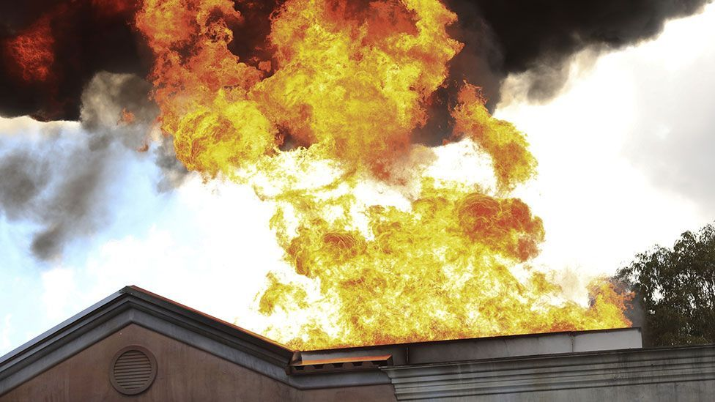
The most important thing is to provide an alternative explanation. An experiment by Hollryn Johnson and Colleen Seifert, shows how to persuade people better. These two psychologists recruited participants to listen to news reports about a fictional warehouse fire, and then answer some comprehension questions.
Some of the participants were told that the fire was started by a short circuit in a closet near some cylinders containing potentially explosive gas. Yet when this information was corrected – by saying the closet was empty – they still clung to the belief.
A follow-up experiment showed the best way to effectively correct such misinformation. The follow-up was similar to the first experiment, except that it involved participants who were given a plausible alternative explanation: that evidence was found that arson caused the fire. It was only those who were given a plausible alternative that were able to let go of the misinformation about the gas cylinders.
Lewandowsky and Cook argue that experiments like these show the dangers of arguing against a misinformed position. If you try and debunk a myth, you may end up reinforcing that belief, strengthening the misinformation in people's mind without making the correct information take hold.
What you must do, they argue, is to start with the plausible alternative (that obviously you believe is correct). If you must mention a myth, you should mention this second, and only after clearly warning people that you're about to discuss something that isn't true.
This debunking advice is also worth bearing in mind if you find yourself clinging to your own beliefs in the face of contradictory facts. You can’t be right all of the time, after all.

Answer the following questions:
1. What myths did Stephen Lewandowsky and John Cook debunk in their Debunker's Handbook?
2. What are “backfire effects”? Under what conditions do “backfire effects” occur?
3. What is the irony of "backfire effects" for communicators?
4. What experiment did Hollryn Johnson and Colleen Seifert do? What results did they find?
5. What is the significance of a plausible alternative explanation for debunking myths?

PART 4. GUIDING TO MORE CALP

Ex. 9. Read the text. Find infographics with the ‘myth vs fact’ formula. Why do such correction strategies may backfire? What kind of content is more effective to spread verifiable information?

SEEING IS BELIEVING: HOW MEDIA MYTHBUSTING CAN ACTUALLY MAKE FALSE BELIEFS STRONGER
(Adopted from The Conversation)
Eryn Newman, Amy Dawel, Madeline Claire Jalbert, Norbert Schwarz

As the COVID-19 pandemic has swept the world, politicians, medical experts and epidemiologists have taught us about flattening curves, contact tracing, R₀ and growth factors. At the same time, we are facing an “infodemic” – an overload of information, in which fact is hard to separate from fiction.
Misinformation about coronavirus can have serious consequences. Widespread myths about “immune boosters”, supposed “cures”, and conspiracy theories linked to 5G radiation have already caused immediate harm. In the long term they make may people more complacent if they have false beliefs about what will protect them from coronavirus.
Social media companies are working to reduce the spread of myths. In contrast, mainstream media and other information channels have in many cases ramped up efforts to address misinformation.
But these efforts may backfire by unintentionally increasing public exposure to false claims.

The ‘myth vs fact’ formula
News media outlets and health and well-being websites have published countless articles on the “myths vs facts” about coronavirus. Typically, articles share a myth in bold font and then address it with a detailed explanation of why it is false.
This communication strategy has been used previously in attempts to combat other health myths such as the ongoing anti-vaccine movement.
One reason for the prevalence of these articles is that readers actively seek them out. The Google search term “myths about coronavirus”, for example, saw a prominent global spike in March.
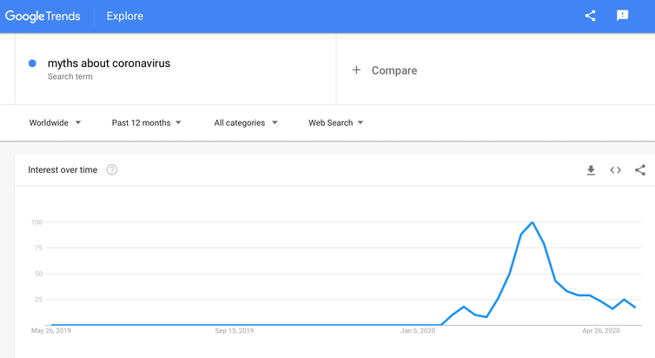
Debunking false information, or contrasting myths with facts, intuitively feels like it should effectively correct myths. But research shows that such correction strategies may actually backfire, by making misinformation seem more familiar and spreading it to new audiences.

Familiarity breeds belief
Cognitive science research shows people are biased to believe a claim if they have seen it before. Even seeing it once or twice may be enough to make the claim more credible.
This bias happens even when people originally think a claim is false, when the claim is not aligned with their own beliefs, and when it seems relatively implausible. What’s more, research shows thinking deeply or being smart does not make you immune to this cognitive bias.
The bias comes from the fact humans are very sensitive to familiarity but we are not very good at tracking where the familiarity comes from, especially over time.
One series of studies illustrates the point. People were shown a series of health and well-being claims one might typically encounter on social media or health blogs. The claims were explicitly tagged as true or false, just like in a “myth vs fact” article.
When participants were asked which claims were true and which were false immediately after seeing them, they usually got it right. But when they were were tested a few days later, they relied more on feelings of familiarity and tended to accept previously seen false claims as true.
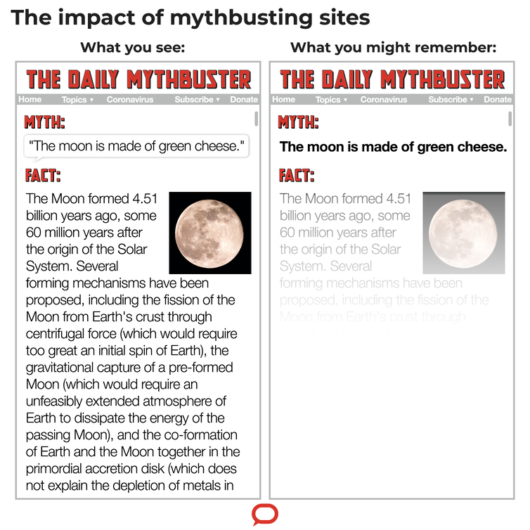
Older adults were especially susceptible to this repetition. The more often they were initially told a claim was false, the more they believed it to be true a few days later.
For example, they may have learned that the claim “shark cartilage is good for your arthritis” is false. But by the time they saw it again a few days later, they had forgotten the details.
All that was left was the feeling they had heard something about shark cartilage and arthritis before, so there might be something to it. The warnings turned false claims into “facts”.
The lesson here is that bringing myths or misinformation into focus can make them more familiar and seem more valid. And worse: “myth vs fact” may end up spreading myths by showing them to new audiences.

What I tell you three times is true
Repeating a myth may also lead people to overestimate how widely it is accepted in the broader community. The more often we hear a myth, the more we will think it is widely believed. And again, we are bad at remembering where we heard it and under what circumstances.
For instance, hearing one person say the same thing three times is almost as effective in suggesting wide acceptance as hearing three different people each say it once.
The concern here is that repeated attempts at correcting a myth in media outlets might mistakenly lead people to believe it is widely accepted in the community.

Memorable myths
Myths can be sticky because they are often concrete, anecdotal and easy to imagine. This is a cognitive recipe for belief. The details required to unwind a myth are often complicated and difficult to remember. Moreover, people may not scroll all the way through the explanation of why a myth is incorrect.
Take for example this piece on coronavirus myths. Although we’d rather not expose you to the myths at all, what we want you to notice is that the fine details needed to debunk a myth are generally more complicated than the myth itself.
Complicated stories are hard to remember. The outcome of such articles may be a sticky myth and a slippery truth.

Making the truth stick
If debunking myths makes them more believable, how do we promote the truth?
When information is vivid and easy to understand, we are more likely to recall it. For instance, we know placing a photograph next to a claim increases the chances people will remember (and believe) the claim.
Making the truth concrete and accessible may help accurate claims dominate the public discourse (and our memories).
Other cognitive tools include using concrete language, repetition, and opportunities to connect information to personal experience, which all work to facilitate memory. Pairing those tools with a focus on truth can help to promote facts at a critical time in human history.

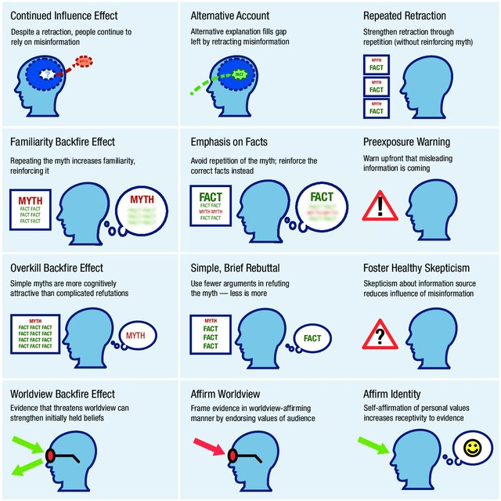
Ex 10. Look at the infographic. In pairs, try to destroy the proposed myths using this algorithm. Exchange the roles of myth supporter and myth destroyer.

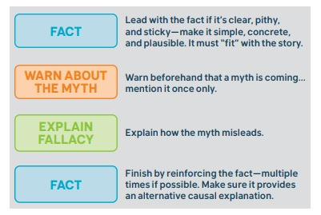
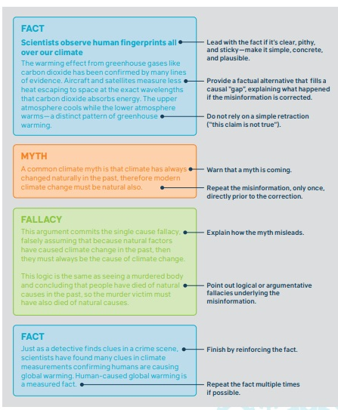
(Adopted from Cook, J., Lewandowsky, S. (2011), The Debunking Handbook. St. Lucia, Australia: University of Queensland. November 5. http://sks.to/debunk)

Myths for exercise
1. Ostriches bury their heads in the sand when frightened
2. Napoleon Bonaparte was extremely short.
3. The Great Wall of China is the only man-made structure visible from space.

Use online sources to find alternative facts.
Remember how to verify the reliability of sites and publications.

PART 5. WRITING

Ex 11. Take fake news trivia quiz (suitable for those aged under 18)


Create quizzes to Test your friends’ fact-checking skills. Collect online true and false stories. Write 5 questions with answers true or false. You can use online quizzes maker Quizziz



PART 6. FURTHER EDUCATIONAL RESOURCES

Ex. 13. Check if you remember the terms and expressions from this unit.
Backfire effect, continued influence effect, debunk, fact, fact-check, fake news, illusory truth effect, infodemic, myt, myth-buster, myth-busting
Ex. 14. Home work
Read texts

How To Recognize A Fake News Story
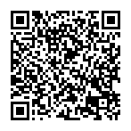

Fake Or Real? How To Self-Check The News And Get The Facts
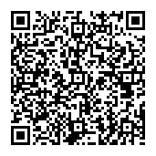

The Fact Checker’s guide for detecting fake news
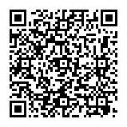
Create visual Fact Checker’s Guide.
List of free infographic makers
- Easel.ly https://www.easel.ly/
- Canva - https://www.canva.com/
- Piktochart - https://piktochart.com/
- Infogr.am - https://infogram.com/
- Visual.ly - https://visual.ly/
- Draw.io - https://app.diagrams.net/

PART 7. REFLECTION

Answer the questions:
- What do I want to learn? What is my learning objective in this seminar?
- What did I learn in this seminar? What was new information to me?
- What am I planning to do with the new knowledge I have attained during the seminar? How will I implement it in my work right now and in the future? Is it relevant to my field of studies?
- How will I continue learning on the topic of multimedia after the seminar?

References:
- Fact checking online is more important than ever - https://www.youtube.com/watch?v=Ryjpu-NWYm8&t=54s
- Olga Yurkova: Inside the fight against Russia's fake news empire - https://www.ted.com/talks/olga_yurkova_inside_the_fight_against_russia_s_fake_news_empire
- Linda Beck: Fact Checking in a Fast-Paced Social Media Driven World - https://www.ted.com/talks/linda_beck_fact_checking_in_a_fast_paced_social_media_driven_world
- Break the Fake: News - https://mediasmarts.ca/quiz/break-fake-news
- Five ways to spot fake news https://www.youtube.com/watch?v=y7eCB2F89K8&ab_channel=Quartz
- “The CRAP Test for Evaluating Websites”. https://www.youtube.com/watch?v=Wpjr35uNnWE&t=37s&ab_channel=ColoradoCommunityCollegesOnline
- “If women in Ukraine love working in tech, why are there so few?” - https://www.kyivpost.com/technology/if-women-in-ukraine-love-working-in-tech-why-are-there-so-few.html
- Keene Info Lit Bank’s CRAP worksheet: http://kscinfolit.wordpress.com/2011/07/12/c-r-a-p-test-map-worksheet-and-handout/.
- Fact vs myth - http://www.differencebetween.net/language/difference-between-fact-and-myth/
- How to debunk falsehoods - https://www.bbc.com/future/article/20141113-the-best-way-to-debunk-myths
- Seeing is believing: how media mythbusting can actually make false beliefs stronger - https://theconversation.com/seeing-is-believing-how-media-mythbusting-can-actually-make-false-beliefs-stronger-138515
- How To Recognize A Fake News Story - https://www.huffpost.com/entry/fake-news-guide-facebook_n_5831c6aae4b058ce7aaba169?section=politics
- Fake Or Real? How To Self-Check The News And Get The Facts - https://www.npr.org/sections/alltechconsidered/2016/12/05/503581220/fake-or-real-how-to-self-check-the-news-and-get-the-facts
- The Fact Checker’s guide for detecting fake news https://www.washingtonpost.com/news/fact-checker/wp/2016/11/22/the-fact-checkers-guide-for-detecting-fake-news/

Further readings:
- Why Do Our Brains Love Fake News?
https://www.youtube.com/watch?v=dNmwvntMF5A&ab_channel=AboveTheNoise
- How to Spot Fake News - FactCheck.org
https://www.youtube.com/watch?v=AkwWcHekMdo&ab_channel=FactCheck
- Deepfakes Are Going To Wreak Havoc On Society. We Are Not Prepared.
https://www.forbes.com/sites/robtoews/2020/05/25/deepfakes-are-going-to-wreak-havoc-on-society-we-are-not-prepared/?fbclid=IwAR1x0m3quedvD3hqqJkbaeidQh16g8FT1EaUlwl-WgiX2lTH2wjRwburuPo&sh=3e2d551f7494
- We need to start reading past the headline, but not for the reasons you think
https://emilyrosethorne.medium.com/we-need-to-start-reading-past-the-headline-but-not-for-the-reasons-you-think-fc64ec53f77b
- How do I check facts on the internet?
https://www.youtube.com/watch?v=_7lAJs9r9Wk&ab_channel=UofGLibrary
- Endless Curiosity: The Science of Fake News
https://www.youtube.com/watch?v=BIv9054dBBI&ab_channel=IndianaUniversity
- Fake News. It's Your Fault.
https://www.youtube.com/watch?v=tRPDwSSjdOM&ab_channel=TEDxTalks
- Cook, J., Lewandowsky, S. (2011), The Debunking Handbook. St. Lucia, Australia: University of Queensland. November 5. http://sks.to/debunk
- Інструменти фактчекінгу: як професійно відрізняти брехню від правди
https://imi.org.ua/articles/instrumenti-faktchekingu-yak-profesiyno-vidriznyati-brehnyu-vid-pravdi-i407
- Про фактчекінг для журналістів і всіх, хто мислить критично
https://www.ukrinform.ua/rubric-society/3157165-pro-faktceking-dla-zurnalistiv-i-vsih-hto-mislit-kriticno.html
- Посібник з верифікації: https://verificationhandbook.com/book_ua/

Glossary:
Backfire Effect - a backfire effect is where a correction inadvertently increases belief in, or reliance on, misinformation relative to a pre-correction or nocorrection baseline.
Continued influence effect - the continued reliance on inaccurate information in people’s memory and reasoning after a credible correction has been presented.
Debunk - to show that something is less important, less good, or less true than it has been made to appear
Fact - something that is known to have happened or to exist, especially something for which proof exists, or about which there is information
Fact-check - to check that all the facts in a piece of writing, a news article, a speech, etc. are correct:
Fake news - false information, often of a sensational nature, that mimics news media content.
Illusory truth effect - repeated information is more likely to be judged true than novel information because it has become more familiar.
Infodemic – an overload of information, in which fact is hard to separate from fiction.
Myth - the generally accepted meaning of myth is of a fictitious (primitive) tale, usually involving supernatural characters embodying some popular idea concerning natural or historical phenomena, and often symbolizing virtues or other timeless qualities. In everyday parlance, a myth is something invented, not true.
Myth-buster - a person, book, etc. that shows that something generally thought to be true is not, in fact, true, or is different from how it is usually described
Myth-busting - saying or showing that something generally thought to be true is not, in fact, true, or is different from how it is usually described

Summative Assessment
- What is a fact?

- Something that is known to have happened or to exist, especially something for which proof exists, or about which there is information
- False information, often of a sensational nature, that mimics news media content.
- A fictitious tale, usually involving supernatural characters embodying some popular idea concerning natural or historical phenomena
- An idea or belief that is not true, or something that is not what it seems to be

- What is mean by ‘fact-check’?

- To show that something is less important, less good, or less true than it has been made to appear
- To check that all the facts in a piece of writing, a news article, a speech, etc. are correct
- To try to discover the truth about someone who is accused of a crime
- The process of getting an understanding of something by studying it or by experience

- What kind of characteristics DOES a myth NOT HAVE?

- Based on the ability to gather scientific evidence as proof of the statement
- Originate from generational thoughts and beliefs, while facts are given as evidence.
- Is generally started to explain away something, or to give a sense of understanding or control over something
- Is often derived through word of mouth, or the reliance on being passed down from generation to generation

- What characteristics DO quality headlines NOT HAVE?

- Neutral
- Balanced
- Emotional
- Objective

- Choose the factual statement in the variants

- Ostriches bury their heads in sand when frightened
- Kyiv is the capital of Ukraine
- Napoleon Bonaparte was extremely short.
- The Great Wall of China is the only man-made structure visible from space.

