What is poetry?
1. a. Read the poem aloud and discuss its meaning with your partner:
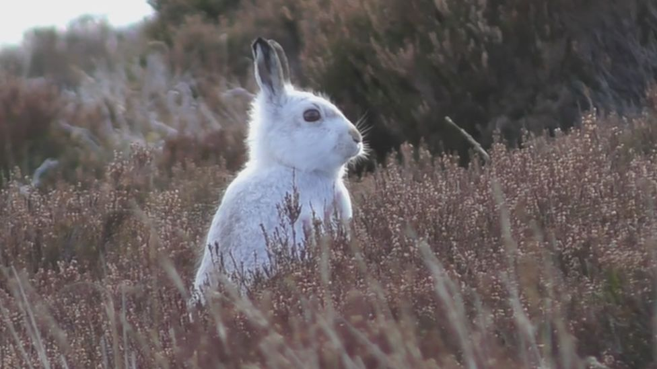
W.B. Yeats (1865–1939)
Memory
ONE had a lovely face,
And two or three had charm,
But charm and face were in vain
Because the mountain grass
Cannot but keep the form
Where the mountain hare has lain.

1.b. Answer the following questions:
1. Why does the poet entitle the poem “Memory”, not “A Memory”/ “The Memory”?
2. What are the images used in the poem?
3. Not that the poem is a complete sentence. What is the rhythm of the poem like?
4. What makes this poem difficult to understand?

2. a. Listen to the poem and fill in the blanks:

Marianne Moore (1887-1972)

Poetry

I too, __________ it: there are things that are important beyond
all this fiddle.
Reading it, however, with a perfect __________ for it, one
discovers in it after all, a place for the ____________.
Hands that can grasp, eyes
that can ________, hair that can rise
if it must, these things are ________ not because a
high-sounding __________ can be put upon them but because
they are
useful; when they become so _________ as to become
unintelligible, the
same thing may be said for all of us—that we
do not admire what
we cannot ____________. The ________,
holding on upside down or in quest of something to
eat, ___________ pushing, a wild horse taking a roll, a tireless
wolf under
a tree, the immovable critic ________ his skin like a horse
that feels a _______, the base-
ball fan, the statistician—nor is it valid
to discriminate against “business documents and
school-books”; all these __________ are important. One must
make a distinction
however: when dragged into prominence by half poets,
the result is not ___________,
nor till the poets among us can be
“literalists of
the imagination”—above
insolence and triviality and can present
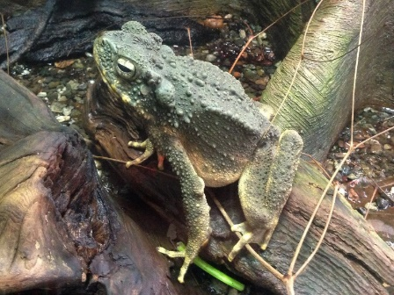
for inspection, imaginary gardens with real toads in them,
shall we have
it. In the meantime, if you demand that on one hand,
the ______ material of poetry in
all its ________, and
that which is on the other hand,
genuine, you are interested in poetry.
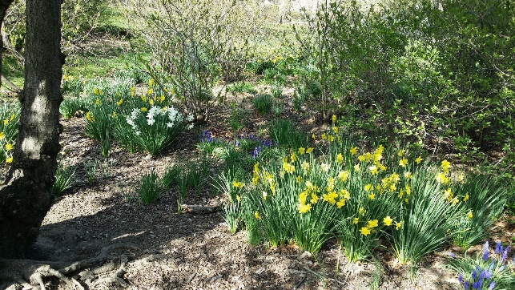
2.b. Answer the questions:
1. What is the poet’s message? What does Marianne Moore really think about poetry? Why does she say “I too, dislike it”? What does she mean by that?
2. What is “fiddle”? Why is this word used here?
3. What does she mean by “imaginary gardens with real toads in them”?
3. Who are “literalists of the imagination”?
4.Who are “half poets”?
5. Do you agree that people dislike everything they don’t understand? Why?

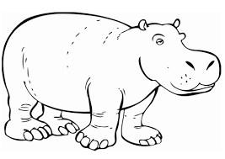
3.a. Restore the order of words within the lines so as to make the poem. Then listen and check:
Ogden Nash (1902-1971)

The Hippopotamus

hippopotamus the Behold!
at laugh he to We looks us how,
grim moments and And yet in dank,
we I to how wonder him look.
thou Peace, hippopotamus peace,!
really We look us all right to,
As eye no the delight doubt you
hippopotami other Of.
3.b. Figure out the meaning of the poem and answer the questions:
1. What is the meaning of the title? Does it have direct link to the message?
2. Define the message of the poem. Is it serious or humorous?
3. What do the words “behold”, “thee” mean? What is the effect of using these poetic words in the context?
4.What is the author’s attitude towards subject-matter and characters? How is it revealed?
4.a. Restore the order of lines within the stanzas so as to make the poem. Then listen and check:
William Blake (1757-1827)

London

And mark in every face I meet
I wander thro' each charter'd street,
Marks of weakness, marks of woe.
Near where the charter'd Thames does flow.

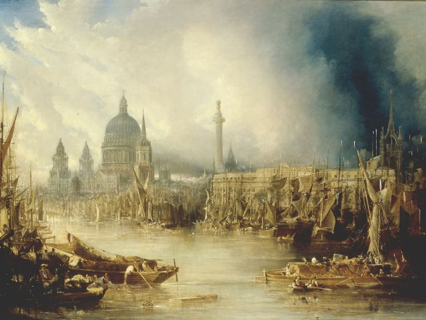
In every cry of every Man,
The mind-forg'd manacles I hear
In every voice: in every ban,
In every Infants cry of fear,

And the hapless Soldiers sigh
How the Chimney-sweepers cry
Runs in blood down Palace walls
Every black’ning Church appalls,

Blasts the new-born Infants tear
But most thro' midnight streets I hear
And blights with plagues the Marriage hearse
How the youthful Harlots curse

4.b. Answer the following questions:
1. What do you learn about London from this poem? How is the setting created?
2. What is the author’s attitude to London? How is it revealed?
3. Does the author use round characters?
4. Does the author aim at objectivity? Explain your point.
5. Do you have the same idea of London? Why?

5.a. Fill in the blanks. Then listen and check:

honey-bees insects sleep miracle roofs miracles miracle miracle miracles miracles naked strangers shining moon miracle hour

Walt Whitman (1819-1892)

Miracles

Why, who makes much of a __________?
As to me I know of nothing else but__________,
Whether I walk the streets of Manhattan,
Or dart my sight over the _________of houses toward the sky,
Or wade with ________ feet along the beach just in the edge of the water,
Or stand under trees in the woods,
Or talk by day with any one I love, or ______ in the bed at night with any one I love,
Or sit at table at dinner with the rest,
Or look at _________ opposite me riding in the car,
Or watch ____________ busy around the hive of a summer forenoon,
Or animals feeding in the fields,
Or birds, or the wonderfulness of ________ in the air,
Or the wonderfulness of the sundown, or of stars ________ so quiet and bright,
Or the exquisite delicate thin curve of the new ________ in spring;
These with the rest, one and all, are to me _________,
The whole referring, yet each distinct and in its place.
To me every _______ of the light and dark is a ________,
Every cubic inch of space is a _________,
Every square yard of the surface of the earth is spread with the same,
Every foot of the interior swarms with the same.
To me the sea is a continual ________,
The fishes that swim—the rocks—the motion of the waves—the
ships with men in them,
What stranger _______ are there?
5.b. Answer the questions:
1. What is the poet’s idea of miracles?
2. What makes this poem a poem?
3. Why does the author use rhetorical questions?
4. What effect does the poem produce on you? Do you agree with the poet?
5. What is a miracle to you?
6. Write a continuation/ answer to the poet’s rhetorical question.

6.a. Match the rhyming words. Read the poem and put the rhyming words in the right places at the ends of lines. Listen and check:

Henry Wadsworth Longfellow (1807-1882)

The Village Blacksmith

Under a spreading chestnut- _________  The village smithy _________ ;  The smith, a mighty man is _________,  With large and sinewy _________;  And the muscles of his brawny _________  Are strong as iron _________. | tree  stands  he  bands  arms  hands
His hair is crisp, and black, and _________ ,  His face is like the _________ ;  His brow is wet with honest _________,  He earns whate'er he _________,  And looks the whole world in the _________ ,  For he owes not any _________. | can,  face  man  long  tan  sweat
Week in, week out, from morn till _________,  You can hear his bellows _________;  You can hear him swing his heavy _________,  With measured beat and _________,  Like a sexton ringing the village _________,  When the evening sun is _________. | bell  blow  low  night  sledge  slow
And children coming home from _________  Look in at the open _________;  They love to see the flaming _________,  And hear the bellows _________,  And catch the burning sparks that _________  Like chaff from a threshing-_________. | door  floor  fly  forge  roar  school
He goes on Sunday to the _________,  And sits among his _________;  He hears the parson pray and _________,  He hears his daughter's _________,  Singing in the village _________,  And it makes his heart _________. | boys  church  choir  preach  rejoice  voice
It sounds to him like her mother's _________,  Singing in _________!  He needs must think of her once _________,  How in the grave she _________;  And with his hard, rough hand he _________  A tear out of his _________. | eyes  lies  more  Paradise  voice  wipes
Toiling,--rejoicing,-- _________,  Onward through life he _________;  Each morning sees some task _________,  Each evening sees it _________  Something attempted, something _________,  Has earned a night's _________. | begin  close  done  goes  repose  sorrowing
Thanks, thanks to thee, my worthy _________,  For the lesson thou hast _________!  Thus at the flaming forge of _________  Our fortunes must be _________;  Thus on its sounding anvil _________  Each burning deed and _________. | friend  life  shaped  taught  thought  wrought

6.b. Answer the following questions:
1. What is the poem about?
2. What is the poet’s attitude to the blacksmith? His work?
3. What is known about the setting? Life of the smith?
4. What features of blacksmith’s appearance and character does the poet stress?
5. What features make the poem song-like?
6. Summarize the poem in prose in up to 10 sentences.

Self-reflection.
What I have learned about poetry so far:
________________________________________________________________________________________________________________________________________________________________________________________________________________________________________________________________________________________________________________________________________________________________________________________________________________________________________________________________________________________________________________________________________________

Chartered= refers to the system of commercial management, or charters, that existed in the city.
Woe= sorrow, distress
Mind-forged = created by mind
Manacles = restrains, cuffs, chains
Hapless = unfortunate, miserable
Appall = disgust, repel
Blast = pump, shatter
Blight = infect
Hearse = vehicle, funeral van
Hive = a place where bees live, a swarm
Sinewy = powerful, strong
Brow = forehead
Morn = morning
Bellows = a device with an air bag that emits a stream of air when squeezed together with two handles, used for blowing air into a fire.
Sexton = bell-ringer
Chaff = waste
Forge = smithy
Parson = minister, priest
Preach = moralise, lecture
Rejoice = celebrate, make merry
Repose = rest, peace
Thee = you
Hast = have
Anvil = a heavy iron block with a flat top and concave sides, on which metal can be hammered and shaped.
Wrought = created, worked

