Read the following poems, paraphrase them, find instances of poetic diction, define their meaning and function(s) and answer the questions:
- O DEATH, ROCK ME ASLEEP
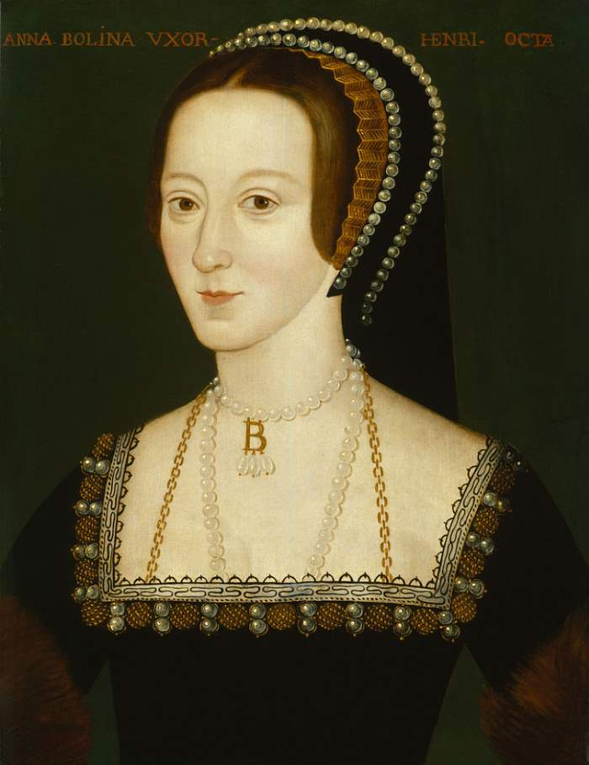
by: Anne Boleyn?
DEATH, rock me asleep,
Bring me to quiet rest,
Let pass my weary guiltless ghost
Out of my careful breast.
Toll on, thou passing bell;
Ring out my doleful knell;
Let thy sound my death tell.
Death doth draw nigh;
There is no remedy.

My pains who can express?
Alas, they are so strong;
My dolour will not suffer strength
My life for to prolong.
Toll on, thou passing bell;
Ring out my doleful knell;
Let thy sound my death tell.
Death doth draw nigh;
There is no remedy.

Alone in prison strong
I wait my destiny.
Woe worth this cruel hap that I
Should taste this misery!
Toll on, thou passing bell;
Ring out my doleful knell;
Let thy sound my death tell.
Death doth draw nigh;
There is no remedy.

Farewell, my pleasures past,
Welcome, my present pain!
I feel my torments so increase
That life cannot remain.
Cease now, thou passing bell;
Rung is my doleful knell;
For the sound my death doth tell.
Death doth draw nigh;
There is no remedy.

1.1.Answer the following questions:
- What do you know about Anne Boleyn and her life?
- What is the main idea of the poem?
- What words are key ones in the poem?
- What is the speaker’s mood and tone?
- How does the speaker make it clear that she has reconciled with her destiny?
- Is there anything to bring consolation to the speaker?

- Written on a Wall at Woodstock
by: Queen Elizabeth I
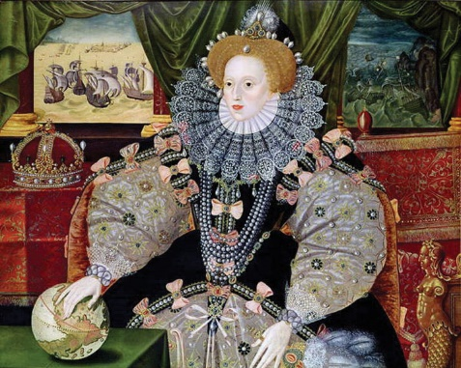
Oh Fortune, thy wresting wavering state
Hath fraught with cares my troubled wit,
Whose witness this present prison late
Could bear, where once was joy’s loan quit.
Thou causedst the guilty to be loosed
From bands where innocents were inclosed,
And caused the guiltless to be reserved,
And freed those that death had well deserved.
But all herein can be nothing wrought,
So God send to my foes all they have thought.
  - Answer the following questions:
- What do you know about Elizabeth I and her life?
- What is the main idea of the poem?
- What words are key ones in the poem?
- What is the speaker’s mood and tone?
- What is the image of Fate that is created in the poem?
- Do you agree with the speaker’s ideas?

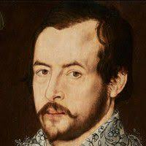
- AUTUMN
by: Thomas Nashe
Autumn hath all the summer's fruitful treasure;
Gone is our sport, fled is poor Croydon's pleasure.
Short days, sharp days, long nights come on apace,
Ah, who shall hide us from the winter's face?
Cold doth increase, the sickness will not cease,
And here we lie, God knows, with little ease.
From winter, plague, and pestilence, good Lord deliver us!
London doth mourn, Lambeth is quite forlorn;
Trades cry, Woe worth that ever they were born.
The want of term is town and city's harm;
Close chambers we do want to keep us warm.
Long banished must we live from our friends;
This low-built house will bring us to our ends.
From winter, plague, and pestilence, good Lord deliver us!
  - Answer the following questions:
- What is your idea of autumn? What is autumn associated with?
- What is the image of autumn that is created in the poem?
- What is the main idea of the poem? How is it revealed?
- What words are key ones in the poem?
- What is the speaker’s mood and tone?

- The Bracelet: To Julia
by: Robert Herrick

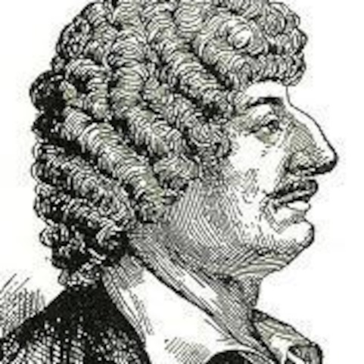
WHY I tie about thy wrist,
Julia, this silken twist;
For what other reason is 't
But to show thee how, in part,
Thou my pretty captive art?
But thy bond-slave is my heart:
'Tis but silk that bindeth thee,
Knap the thread and thou art free;
But 'tis otherwise with me:
—I am bound and fast bound, so
That from thee I cannot go;
If I could, I would not so.
  - Answer the following questions:
- What is the main idea of the poem?
- How is it presented?
- What words are key ones in the poem?
- What is the speaker’s mood and tone?
- What kind of love is presented in the poem?

- Anacreontics, the Epicure
by: Abraham Cowley

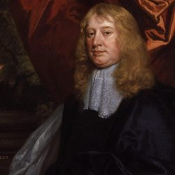
UNDERNEATH this myrtle shade,
On flowerly beds supinely laid,
With odorous oils my head o'erflowing,
And around it roses growing,
What should I do but drink away
The heat and troubles of the day?
In this more than kingly state
Love himself on me shall wait.
Fill to me, Love! nay, fill it up!
And mingled cast into the cup
Wit and mirth and noble fires,
Vigorous health and gay desires.
The wheel of life no less will stay
In a smooth than ruggèd way:
Since it equally doth flee,
Let the motion pleasant be.
Why do we precious ointments shower?—
Nobler wines why do we pour?—
Beauteous flowers why do we spread
Upon the monuments of the dead?
Nothing they but dust can show,
Or bones that hasten to be so.
Crown me with roses while I live,
Now your wines and ointments give:
After death I nothing crave,
Let me alive my pleasures have:
All are Stoics in the grave.
  - Answer the following questions:
- What is the main idea of the poem?
- How is it presented?
- What words are key ones in the poem?
- What is the speaker’s mood and tone?
- Who is an epicure? Stoic?

- ON HER LOVING TWO EQUALLY
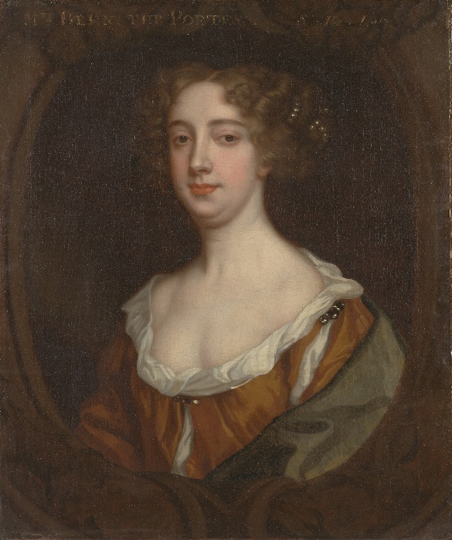
by: Aphra Behn
I.
OW strongly does my passion flow,
Divided equally 'twixt two?
Damon had ne'er subdued my heart,
Had not Alexis took his part;
Nor could Alexis powerful prove,
Without my Damon's aid, to gain my love.
II.
When my Alexis present is,
Then I for Damon sigh and mourn;
But when Alexis I do miss,
Damon gains nothing but my scorn.
But if it chance they both are by,
For both alike I languish, sigh, and die.

III.
Cure then, thou mighty wingèd god,
This restless fever in my blood;
One golden-pointed dart take back:
But which, O Cupid, wilt thou take?
If Damon's, all my hopes are crossed;
Or that of my Alexis, I am lost.
.
6.2. Answer the following questions:
- What is the main idea of the poem?
- How is it presented?
- What is the speaker’s mood and tone?
- What is the speaker’s dilemma?
- What advice would you give to the speaker?

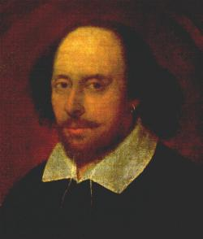
7.Sonnet XXVII
by: William Shakespeare
Weary with toil, I haste me to my bed,
The dear repose for limbs with travel tired;
But then begins a journey in my head
To work my mind, when body's work's expired:
For then my thoughts--from far where I abide--
Intend a zealous pilgrimage to thee,
And keep my drooping eyelids open wide,
Looking on darkness which the blind do see:
Save that my soul's imaginary sight
Presents thy shadow to my sightless view,
Which, like a jewel hung in ghastly night,
Makes black night beauteous, and her old face new.
Lo! thus, by day my limbs, by night my mind,
For thee, and for myself, no quiet find.

  - Answer the following questions:
- What is the main idea of the poem?
- What words give you the idea that the person is tired but relaxed at the same time?
- What is the speaker’s dilemma?
- Why does the speaker use the words “zealous” and “pilgrimage” when talking about his state?
- What advice would you give to the speaker?

