Практичне заняття 10
- Complete the task. In your opinion, what of the information suggested in the text can a teacher use in his or her profession? Provide arguments.
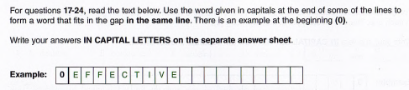
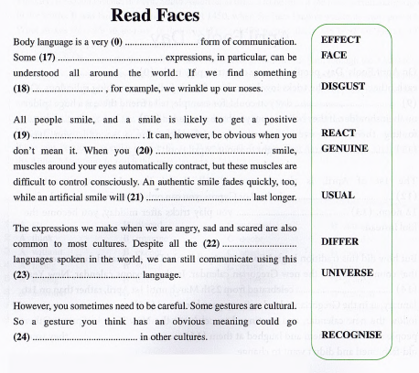

- 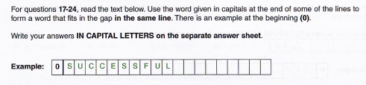
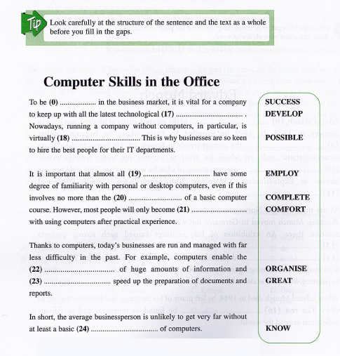

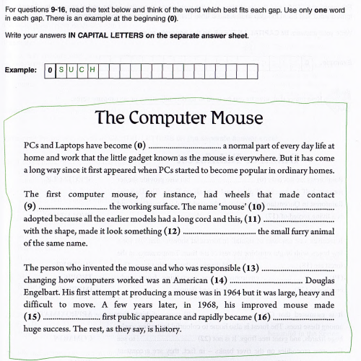

Волкова В. В. Ділова риторика і міжкультурна комунікація : курс лекцій для здобувачів ступеня вищої освіти магістра спеціальності «Міжнародні відносини, суспільні комунікації та регіональні студії» освітньо-професійної програми «Країнознавство»
Here are a few key tips for increasing the effectiveness of your oratorical delivery.
- Master the pause. Most people are so nervous when they get up to speak that they rush through the whole thing. But they are losing out on employing one of the most powerful oratorical techniques – the pause. A pause can add a bit of dramatic flair to a statement or it can help the audience really drink up an idea. The key with a pause is timing. Use it only in spots where it will be effective – places where you really want to highlight what comes after the pause. “Hello (pause) my (pause) name is (pause),” would not be such a time. Practice inserting pauses in your speech to find what works.
- Watch your body language. When you are speaking, your voice is not the only thing talking. Your body is also communicating. Your posture, head tilt, and the way you walk on stage all convey a message. Some occasions may require that you carry yourself in a more formal and stiff manner, while other occasions will require a more laid-back approach.
- Vary your tone. Nothing will put your audience to sleep faster than a visit from android man from the year 2050. Short-circuit the flat, monotonous robot voice and keep things interesting by adding vocal inflections as you speak. Use inflections to reveal that you’re asking a question, being sarcastic, or conveying excitement. You might even exaggerate your inflections when delivering a public speech as many people have a tendency to get timid in front of an audience.
- Let gestures flow naturally. If used effectively, hand gestures can give added emphasis to your words. If used incorrectly, you will end up looking like an octopus having a seizure. Do not overthink hand gestures; just let them flow naturally. You might want to have someone watch you practice the speech to make sure your gesticulations are not distracting. If they are, adjust accordingly, but do not obsess about it; they are part of what makes you unique as a speaker.
- Match your speed with your emotion. How fast or slow you speak can affect the emotion you are trying to convey. There are six different speech speeds and the corresponding emotions they are meant to elicit. They are as follows:
- Rapid: haste, alarm, confusion, anger, vexation, fear, revenge, and extreme terror.
- Quick or brisk: joy, hope, playfulness, and humour.
- Moderate: good for narration, descriptions, and teaching.
- Slow: gloom, sorrow, melancholy, grief, pity, admiration, reverence, dignity, authority, awe, power, and majesty.
- Very slow: used to express the strongest and deepest emotions.
- Vary the force of your voice. Force is the strength and weakness of voice. Varying the force of your voice can help express different emotions. Anger, ferocity, and seriousness can be conveyed with a strong, loud voice. This does not mean you need to shout. You just need to put a little more oomph in your voice. A softer voice can convey reverence, meekness, and humility. Varying the force of your voice can also help draw listeners into your speech. For example, by speaking softly, your audience has to work a bit more to hear you. It is almost like you are telling a secret to your audience which is a great way to emphasis a point you are making and to connect with your listeners. Like all tactics, this must be used sparingly…don’t make the audience strain to hear your whole speech.
- Enunciate. It is easy to trip over your tongue and slur words together when you are speaking in public. But really focus on enunciating your words as this will make you easier to understand. I have a tendency to mumble and slur words together. A trick that has helped me overcome this is practicing speaking while holding a pencil underneath my tongue. It forces your tongue to work harder as it restricts tongue movement. When you remove the pencil from underneath your tongue, you will be amazed at how much easier it is to enunciate without the obstruction. Tongue twisters help with enunciation, too.
- Look your audience in the eye. When you look people in the eye, you make a connection. But how can you look an entire audience in the eye? Well, if there are hundreds of people in your audience, you cannot. But you can at least make eye contact with a couple of them. As you go through your speech, work your way across the room making eye contact with several different people in the audience. You will get a strong connection with those people you look in the eye, but you will also give everyone else a chance to look you in the face which can help build a connection. Maintain contact for a few seconds. If it is too short, you will seem nervous and shifty. If you look too long, you will start creeping people out.

