Practical classes 11-12
Task 1. Follow the example
1)
2)
3)
4)

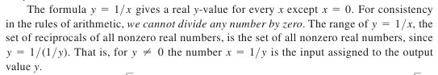

Task 2. Provide comments on the figure according to the definition
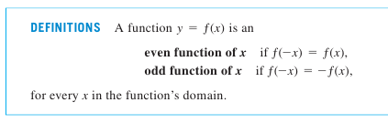
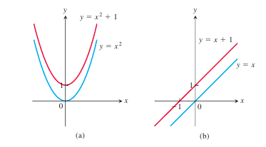

Task 3.
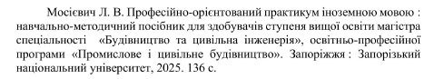
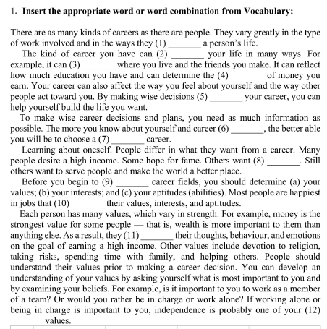

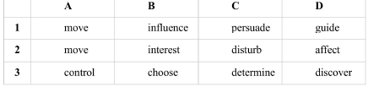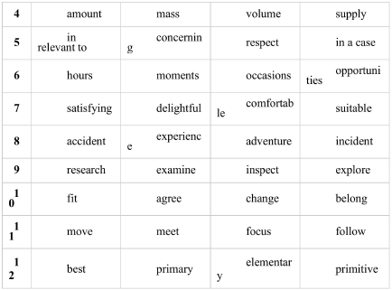

Task 4.
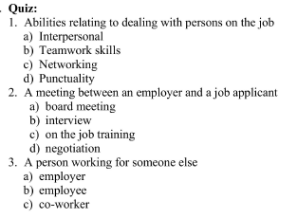
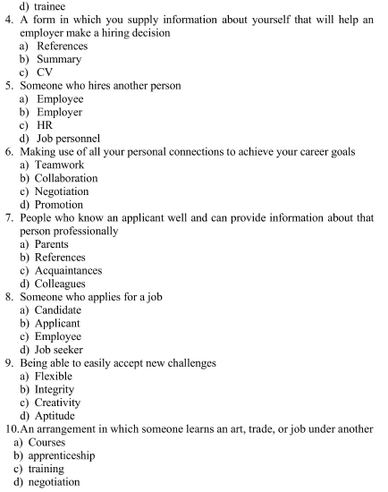

Task 5. Read the presentation. Make a scientific analysis of the material presented in it. Use at least 10 words or phrases from the list provided
“”
(pp. 1-14, 21-22, 30-36, 43-44, 50-51, 61-66)

To task 1.

- 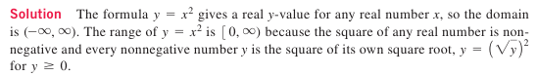
- 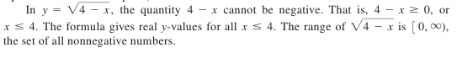
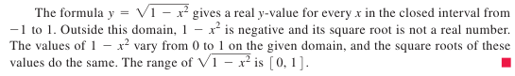
To task 2
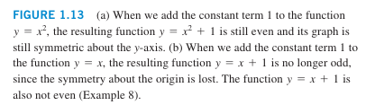
To task 5.
