a / an is used:
a /an is not used:

The is used: The is not used:
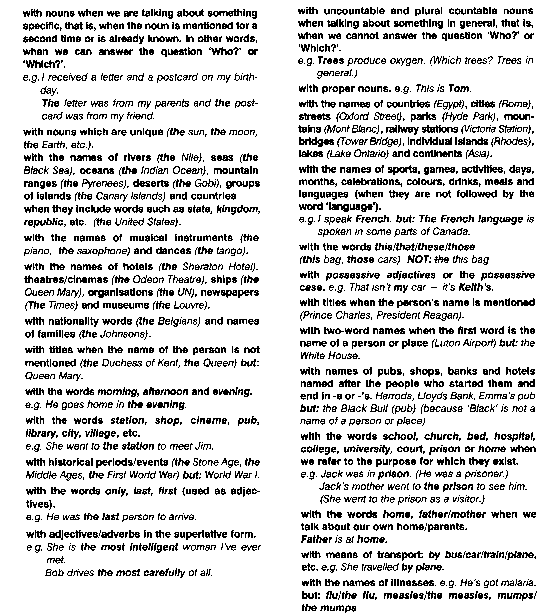
We use the + adjective (without a noun) to refer to a group of people usually with these adjectives: poor, rich, sick, injured, elderly, disabled, young, unemployed, dead, deaf, blind, homeless etc. e.g. We should respect the elderly.
When we want to refer to a group of people, animals or things, we can use:
1. a /an or the with singular countable nouns.
e.g. A / The lion is a wild animal. (We mean all lions)
2. plural countable nouns without a /an or the.
e.g. Lions are wild animals. (NOT: The lions are wild animals)

