UNIT 5
PAINTING

WARMING UP ACTIVITIES

I. Look at the pictures. How has art evolved since Da Vinci’s times?
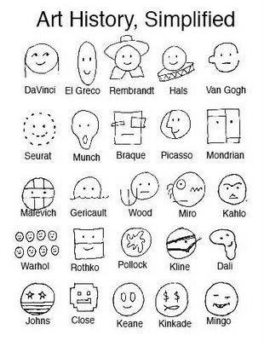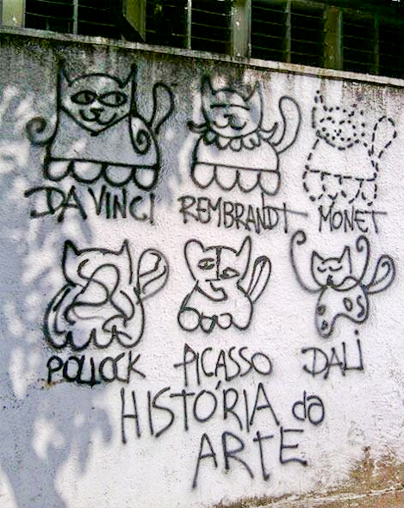

What is your favourite trend? Who is your favourite artist?

CORE ACTIVITIES

ESSENTIAL COURSE TOOLKIT

A. SPEECH PATTERNS – FIELD STUDIES
Translate into Ukrainian, paying attention to the usage of the speech patterns. Pay attention to the fact that these sentences were taken from real life context.

1. can't do anything with - Unable to cope with or manage someone or something. For example, I can't do anything with my hair, or My teenage daughter is very difficult I can't do anything with her. This expression uses “do” in the sense of “deal with,” a usage dating from the early 1500s. (http://dictionary.reference.com)
2. Do some thinking before filing for divorce: Is there still an emotional connection? Is your desire to divorce based on an emotional reaction or true self-awareness? Do you have what it takes to get through the divorce process? (http://www.firstwivesworld.com)
3. No Easy Day: The Firsthand Account of the Mission that Killed Osama bin Laden is a military memoir of "Mark Owen", subsequently identified as Matt Bissonnette, who participated in the mission that resulted in the death of Osama bin Laden. (a real book title)
4. Carolina Mudcats prove too much for Myrtle Beach Pelicans: The Pelicans were unable to battle back as they fell to the Carolina Mudcats 4-3 to tie the series on Friday. (Sports news)
5. -"All I'm writing is just what I feel, that's all. I just keep it almost naked. And probably the words are so bland." (Jimi Hendrix)
6. “Go for broke. Always try and do too much. Dispense with safety nets. Take a deep breath before you begin talking. Aim for the stars. Keep grinning. Be bloody-minded. Argue with the world. And never forget that writing is as close as we get to keeping a hold on the thousand and one things - childhood, certainties, cities, doubts, dreams, instants, phrases, parents, loves - that go on slipping, like sand, through our fingers.” (Salman Rushdie)
7. Let's Make It Tuesday... Sticky Buns: Running a little behind.... (that's been a trend lately). However, I just had to share with everyone, that I finally got around to making the Sticky Buns that I had posted a week or so ago on What I Found Friday. (http://blogittybbb.blogspot.com)

B. LOOKING BEYOND THE TEXT
Read R. Golberg’s biography. What kind of person was he? How can his biography help you better understand his work (p.140-144)?

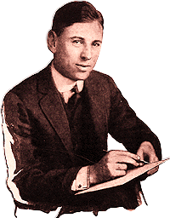
Rueben Garret Lucius Goldberg was born on July 4th 1883 in San Francisco . By the end of his lifetime in December 7th 1970, he was known as an inventor, sculptor, author, engineer and cartoonist and would make a mark in history for his extraordinary achievements.

At a young age, he loved drawing, tracing and being creative but this was discouraged by his parents. In 1900 he graduated from Lowell High School in San Francisco and in 1904, he graduated with a degree in engineering from the University of California, Berkeley. He was then hired as an engineer by the city of San Francisco but eventually quit to become a sports cartoonist for the San Francisco Chronicle but left only a year later to work with the San Francisco Bulletin. In 1907 he moved to New York where he worked for several newspapers and by 1915, soon found national acclaim as a copious artist. He married Irma Seeman in 1916 and had two children, Thomas and George. When World War II came along, he demanded his sons change their name for their protection as he was receiving hate mail due to his controversial political cartoons. One son became a painter, the other a Hollywood writer and producer. In 1938, Rube Goldberg gave up cartooning and wrote popular articles and stories but returned to editorial cartooning for the New York Sun. Later, he was employed by the New York Journal America until his retirement in 1964 where thereafter he made bronze sculptors.

His cartoon strips were popular but the work that gave him unforgettable lifelong fame was the character he created, Professor Lucifer Gorgonzola Butts. Using the character, he would illustrate inventions that later become known as the “Rube Goldberg Machine”. A “Rube Goldberg Machine” is an extremely complicated device that executes a very simple task in a complex, indirect way. This is now used as an expression to describe any system that's confusing or complicated and came about from Goldberg's illustrations of absurd machines.

The National Cartoonists Society, in which Goldberg was the first president, named the Rueben Award in his honor, to recognize the “Cartoonist of the Year”. In high schools and universities worldwide, there are Rube Goldberg contests which challenge students to create intricate machines to do easy tasks. In 1995, his drawing of “Rube Goldberg's Machines” depicting Professor Butts with the Self Operating Napkin was included in the classic comic strips for the commemorated USA postage stamps.
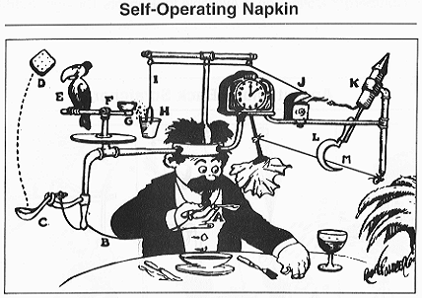

Goldberg has won awards including 1948 Pulitzer Prize for his drawing about the world being on the edge of nuclear devastation, and has received several awards from the National Cartoonists Society including the Gold T-Square Award in 1955, the 1969 Rueben Award and the Gold Key Award, after his death in 1970. To further add to this list of accomplishments, he won the Banshee's Silver Lady Award in 1959, he was a co-founder of the Famous Artists School, President of the Artists and Writers Club and a member of the Society of Illustrators.

His work has appeared in many shows, with the last one being in 1970 in Washington at the National Museum of American History. This was only a few weeks prior to his death and the show exhibited his lifelong accomplishments and he was the first ever cartoonist to be so privileged. His whole life was spent creating, thinking and inventing. As Rube Goldberg himself once said, “I do not count the years. Tomorrow is just another day to create something I hope will be worthwhile.”
Sources:
http://www.rube-goldberg.com/
http://rube.iscool.net

C. ESSENTIAL VOCABULARY CHALLENGE

Study the additions to the essential vocabulary (p. 11-14). Do the following activities:
a) translate them into Ukrainian
b) explain them using English-English dictionary
c) make up a vocabulary story using them as key-words
d) explain the cultural allusions
e) comment on the proverbs
f) find your own synonyms, antonyms and other interesting additions to the vocabulary list
1. relieve
- to relieve a person of his cash
- to relieve smb. from / of his post
Usage note: If someone is relieved of their duties or is relieved of their post, they are told that they are no longer required to continue in their job.
e.g. The officer involved was relieved of his duties because he had violated strict guidelines.
Usage example: to relieve someone of smth. - to take (a burden) from someone he relieved her of her baggage
Euphemism: to relieve oneself - used as a formal or euphemistic expression for urination or defecation
2. art
- art of conversation
- martial art
- art of healing
- art dealer
- art paper
- art director
- to art up
Idiom: to have / be art and part in smth. - take part in
Cultural allusion: art for art's sake - used to convey the idea that the chief or only aim of a work of art is the self-expression of the individual artist who creates it
Cultural allusion: art-house - An art-house film is a film that is intended to be a serious artistic work rather than a piece of popular entertainment.
3. draw
- draw a check
- draw a conclusion
- to draw a line
- to draw a parallel
- to draw a sword
- to draw money from a bank
- to draw back from the deal at the last moment
- to draw one's first breath / draw one's last breath
- to draw the moral
Phrasal verb: to draw on - to use one's experience, talents, or skills as a resource
e.g. Sue has a lot of past experience to draw on.
to draw smth. up – to prepare a plan, agreement, or other document in detail
e.g. They instructed an attorney to draw up a sales agreement.
Idiom: to draw a bead on smb. – to aim at smb.; have an eye on smb. or smth.
to draw someone's fire - to attract hostile criticism away from a more important target
to draw a blank - a) to choose a lottery ticket that fails to win b) to get no results from something
to draw a veil / a curtain over – to avoid discussing or calling attention to (something), esp. because it is embarrassing or unpleasant
to draw the short straw - to be the unluckiest of a group of people, esp. in being chosen to perform an unpleasant task
4. picture
- picture book
- picture freeze
- picture frequency
- to be in the picture
- to be out of the picture
- to go to the pictures
- (as) pretty as a picture
Usage example: a picture - an image in your mind, a mental picture
e.g. I have such happy pictures in my mind of those times.
e.g She had a mental picture of Samuel's face.
Usage example: picture marriage - a marriage (as between persons living in different countries) contracted after acquaintance only by an exchange of photographs; such a marriage effected by a ceremony in the absence of the groom for the purpose of entitling the bride to enter the country of the groom's residence
Collocations:
- accurate, clear, complete, confused, detailed, full, gloomy, vivid picture
- convey, create, give, paint, present, provide, show a picture
5. paint
- blob / speck of paint
- coat of paint
Usage example: war paint – 1) paint that some people, for example native americans, traditionally put on their face and body when they went into battle
2) (humorous) make-up
Idiom: to paint the town red (informal) - to enjoy yourself by going to places such as bars and clubs
Idiom: to paint smb. black – to blacken smb's reputation
Idiom: like watching paint dry (of an activity or experience) extremely boring
6. colour
- colour pan
- primary / simple / fundamental colours
- colour discrimination
- to dress in colours
- local colour
- food colours (e.g. It is better to avoid all food colours)
- hair colour (e.g. The Body Shop Herbal Hair Colour)
Usage example: in colour – of some particular colour
e.g. His hair is reddish in colour.
Usage example: to add/give/bring colour to something – to arouse more interest or excitement
e.g. The examples chosen add colour to the writing.
Idiom: to see the colour of someone's money (informal) - to have proof that someone is going to pay you
7. doubt
- nagging/lingering doubts
- deep/strong/grave/serious doubts
- gnawing / nagging doubts
- to doubt one's own eyes
- to cast doubt on
- to express / voice (a) doubt
- to feel / entertain / harbor doubts about smth.
Usage example: to be in doubt
1) if you are in doubt about something, you do not know what to do about it
e.g. He is still in some doubt about whether to go or not.
2) if something is in doubt, it is not certain whether it will succeed or continue to exist
e.g. The future of the company is still in doubt.
Usage example: open to doubt - not definite, and perhaps not even likely
e.g. It is now open to doubt whether the concert will go ahead.
Acronym: WIDLIO - When in Doubt, Leave It Out – if you are uncertain about something, don’t do it, drop it or avoid it
8. select
- to select out
- to select from a range of quality products
Derivatives: selectable, selectness
Related items: to select - choose, pick (out), single out, sort out, decide on, settle on, determine, nominate, appoint, elect
Usage example: select (as an adjective) - chosen from a number or group by fitness or preference; exclusively or fastidiously chosen often with regard to social, economic, or cultural characteristics
e.g. The group was small and select. He only drinks select wines.
9. size
- in size
- king-size
- queen-size
- full-size
- crew size
- to size up
Usage example: size - actual state of affairs
e.g. That's about the size of it.
Idiom: to try it for size - to test something or to think about an idea in order to decide whether it works or whether you can use it
e.g. Try that for size. It's the new software program I've been working on.
10. effort
- useless / vain / wasted efforts
- Herculean / heroic / painstaking / strenuous / valiant effort
- ceaseless / unceasing efforts
- combined / collaborative / concerted / joint efforts
- desperate / frantic efforts
- to put effort into something
- to be an effort
Usage example: despite someone's effort
e.g. The man died despite the doctors' efforts to revive him.
Usage example: An effort can be defined as a particular series of activities that is organized by a group of people in order to achieve something.
e.g. ...a famine relief effort in Angola.
Usage note: When you put a lot of effort into doing something, it is like using a part of your body.
- Does she have the backbone to stand up to them? Or will she just give in?
- You have to put your back into it.
- They only succeeded by using their political muscle.
- Put a bit more elbow grease into it.
- My heart's not really in it.
- I had to sweat my guts out to get it done in time.
- We must all put our shoulders to the wheel.
- Just try to put your best foot forward now.
- I've been keeping my nose to the grindstone.
- He was the kind of boss who liked to get his hands dirty.

D. TOPICAL VOCABULARY UPDATE

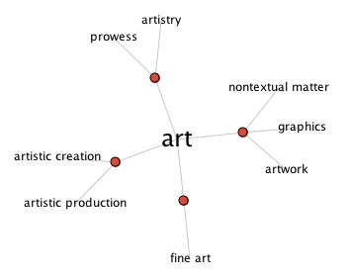
I. Look at the diagram was produced with Plumb Design and Thinkmap.com's Visual Thesaurus - an animated display of words and meanings - a visual representation of the English language. Explain the four main meanings of the word. Create your own diagrams for the following words: artist, artistic, masterpiece, gallery, inspiration.
II. Read the article about the word “art” from the ArtLex dictionary (http://www.artlex.com/). Underline all the words connected with the world of art. Explain their meaning. Find the derivatives of the word “art” and comment on their usage.

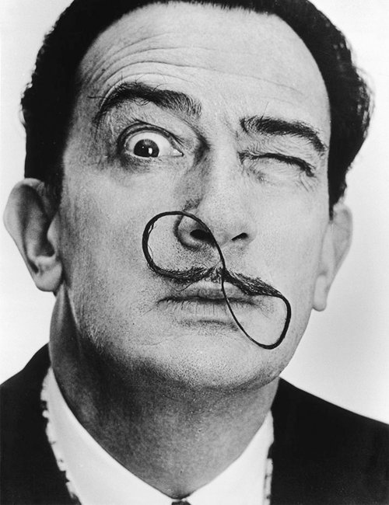
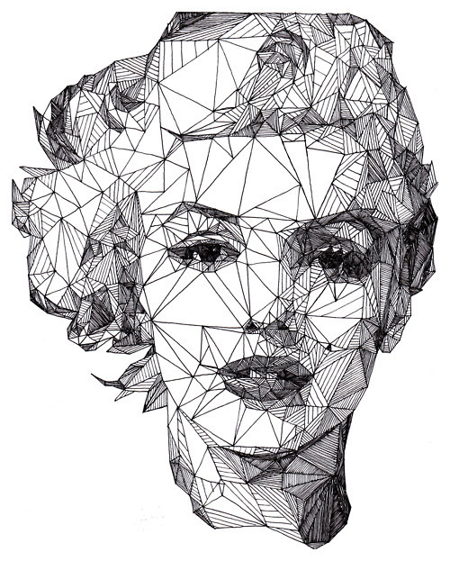
For numerous reasons, a difficult word to define without starting endless argument! Many definitions have been proposed. At least art involves a degree of human involvement — through manual skills or thought — as with the word "artificial," meaning made by humans instead of by nature. Definitions vary in how they divide all that is artificial into what is and isn't art. The most common means is to rely upon the estimations of art experts and institutions.

Artists, museum curators, art patrons, art educators, art critics, art historians, and others involved with art change their ideas about it over time. Early in the twentieth century, for instance, artists expanded the definition of art to include such things as abstraction, collage, and ready-mades. Even in the second half of the twentieth century, the artworld expanded its definition of art to include textiles, costumes, jewelry, photography, video, concepts, and performances as art. Only in the last ten or twenty years works of various native peoples have come to be considered art rather than artifacts.

However, people of some cultures do not (or refuse to) refer to some works as "art." Because of this, many people have taken to using the broader terms - material culture or visual culture - when referring to such works. No American Indian language includes such a word as art. The Japanese created such a word only after coming into contact with European ideas.

E. PILOT PROJECT

Art is always connected with creativity. A lot of creative projects are connected with art, painting, pictures, art experiments and so on. For example, there is The Museum Of Bad Art (MOBA), which is the world's only museum dedicated to the collection, preservation, exhibition and celebration of bad art in all its forms. MOBA maintains a website (http://www.museumofbadart.org) as well as three bricks-and-mortar galleries, all in the Boston, MA area. They have such collections as:
portraiture
Artists who make it into the MOBA portraiture collection are often visited by a unique, possibly extraterrestrial muse.
landscape
Are those ice creams or mountains?
unseen forces
It is not an easy thing to struggle against mighty forces like the giant orange cat consuming humankind.

a) Choose one of the pictures from the MOBA collection and give your competent opinion.
b) Find a creative project connected with art (a museum, a website, a book, a video etc.) and create a presentation, say why it might be interesting for others and share your own impressions.

EXTRA TOOLS

I. Match the famous person with the quote. Explain your choice.
- The holy grail is to spend less time making the picture than it takes people to look at it.  - Our society is run by insane people for insane objectives. I think we're being run by maniacs for maniacal ends and I think I'm liable to be put away as insane for expressing that. That's what's insane about it.  - I've never believed in God, but I believe in Picasso.  - It takes a long time for a man to look like his portrait.  - You come to nature with all her theories, and she knocks them all flat.  - The true work of art is but a shadow of the divine perfection.  - A picture is worth a thousand words.  - An artist is somebody who produces things that people don't need to have.  - Art is the most intense mode of individualism that the world has known. | - Michelangelo  - Oscar Wilde  - Napoleon Bonaparte  - James McNeill Whistler  - John Lennon  - Banksy  - Renoir  - Andy Warhol  - Diego Rivera

II. Guess the author of each quote: Andy Warhol, Banksy, Salvador Dali, Leonardo da Vinci, Michelangelo, Pablo Picasso, Vincent van Gogh. Comment upon it. What do you know about the author of the quote?

- I am not strictly speaking mad, for my mind is absolutely normal in the intervals, and even more so than before. But during the attacks it is terrible - and then I lose consciousness of everything. But that spurs me on to work and to seriousness, as a miner who is always in danger makes haste in what he does.

- When we discovered Cubism, we did not have the aim of discovering Cubism. We only wanted to express what was in us.

- If people knew how hard I worked to get my mastery, it wouldn't seem so wonderful at all.

- You know what hip-hop has done with the word 'nigger' - I'm trying to do that with the word vandalism, bring it back.

- Why do people think artists are special? It's just another job.

- People love mystery, and that is why they love my paintings.

- Where the spirit does not work with the hand there is no art.

REVISION AND SELF-CONTROL ACTIVITIES

Variant I

I. Paraphrase the following sentences using speech patterns:
1. I am at my wits’ end, Paul refuses to go to school.
2. I used to go fishing in my younger days.
3. I had not expected that the film might be so thrilling.
4. He showed very little skill.
5. We could meet on Monday, Wednesday and Friday.

II. Make as many sentences with the vocabulary unit “draw” using it in its different meanings as you can.

III. Translate the sentences into English.
1. Поза сумнівом, він - творча особистість.
2. У той час він був уже зрілим художником і дивився на всіх аматорів критично.
3. Дозвольте мені взяти Вашу сумку.
4. Він докладав усіх зусиль, щоб бути в хорошій формі.
5. Він вибрав рукавички на розмір більше.
6. Він написав прекрасний натюрморт.
7. Перед самим кінцем виставки моєму другові вручили приз.
8. Новина про те, що мою картину взяли до показу, принесла мені полегшення.
9. Я купив кілька тюбиків масляних фарб і коробку акварелі.
10. Він - прекрасний колорист, але при цьому жахливо нудна людина.

IV. Answer the questions using the topical vocabulary and the essential vocabulary:
1. Who is Collis P. Ellsworth? Describe his appearance and character.
2. What are the main functions of art in our life? (give your own opinion)

Variant II

I. Paraphrase the following sentences using speech patterns:
1. I’ve been thinking about it a good deal.
2. Unfortunately I can’t make her eat porridge in the morning.
3. I’d never have believed that Jacob would turn out to be a hero.
4. This was an extraordinary case.
5. Make an effort to draw that vase over there.

II. Write as many words and word-combinations including the vocabulary unit “colour” as you can.

III. Translate the sentences into English.
1. У неї така натягнута усмішка, що я відчув полегшення, коли вона пішла.
2. Мрією всього його життя було стати хорошим пейзажистом.
3. Коли друг сказав мені, що мені пора відправити одяг у чистку, я почервонів до коренів волосся.
4. Старий не хотів братися за живопис, тому що боявся стати посміховиськом.
5. Немає сумнівів, вони повісять мій портрет в самому непомітному місці.
6. Я вибрав цю картину, тому що мені сподобалася гамма кольорів.
7. Він доклав всіх зусиль, щоб стати хорошим колористом, і часто працював з великим збитком для здоров'я.
8. Поквапся! Ти все ще можеш відвернути катастрофу.
9. Він черпав натхнення в природі і завжди вибирав найбільш мальовничі краєвиди.
10. Дозвольте мені взяти Ваш чемодан.

IV. Answer the questions using the topical vocabulary and the essential vocabulary:
1. The story tells us about the two pictures. Describe them.
2. Give your own opinion concerning the statement: “Art’s nothing, money is everything”

SELF-STUDY ACTIVITIES

Text 12: JOSHUA REYNOLDS

Pre-reading task
- Who is your favorite artist? What is your favorite picture?
- What English painters do you know?
- What art galleries, either foreign or home, do you know? Have you visited any of them?

While reading

You are going to read the description of the picture “The morning walk”. Choose from the list below the best sentence to fill in the blanks in the article. There is one extra sentence which you do not need to use.

- This charming picture belongs to Gainsborough's early period, when he was working in London and Suffolk.
- Being only a dog with no sense of occasion he pants joyfully hoping for attention.
- But this rapturous manner of painting, in which all parts of a canvas were worked on together with a flickering brush, only appears in mature works, such as this famous and splendid picture.
- William Hallett was 21 and his wife Elizabeth 20 when they solemnly linked arms to walk in step together through life.
- Both were to be decisive, and the effects are best judged in his portraits of women sitters, on the scale of life, in which elegance and ease of manner combine with a new, more tender colour range and a loosening of paint texture.
- Gainsborough continues to enchant us, as the serious Reynolds seldom can.
- Some time in 1756 he sat for Reynolds.
- Although he did not achieve greatness as a 'history painter', he invested his innumerable portraits of the privileged men and women of English society with the wit, poetic resonance and nobility of heroic narrative.
- Even his contemporaries protested at his technical shortcomings.

Now read the text and do the exercises.

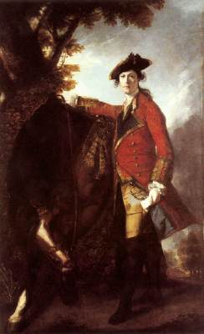
Joshua Reynolds

Captain Robert Orme (1756)

Oil on canvas, 240 x 147 cm
National Gallery, London

Joshua Reynolds, third son and seventh child of the Reverend Samuel Reynolds, was apprenticed at seventeen in London to the portrait painter Thomas Hudson, a Devonshire man like himself. Despite the uninspired example of Hudson, Reynolds succeeded in his ambition to become no 'ordinary' craftsman-painter: he established himself as a fashionable portrait painter, became friends with the most eminent men of letters in England, first president of the newly formed Royal Academy in 1768, and was knighted in 1769. 1)____________
His fifteen Discourses on Art, delivered at the Academy between 1769 and 1790, remain the most cogent and most moving tribute in English to the ideals of Western art grounded in the Italian Renaissance.
We now tend to prefer the fresher brush of his rival Gainsborough to Reynolds's contrivances. A restless and indiscriminate experimenter with media and pigments, imitating the surface effects of Old Master paintings without an understanding of their methods, he saw his pictures fade, flake and crack, so that portraits 'died' before their sitters. 2)____________Yet the more we look at Reynolds, in the prodigious variety which Gainsborough rightly envied, the more we see that he indeed achieved what he defined as 'that one great idea, which gives to painting its true dignity...of speaking to the heart'. More than any English painter before him, in the 'great design' of 'captivating the imagination', Reynolds participated in 'that friendly intercourse which ought to exist among Artists, of receiving from the dead and giving to the living, and perhaps to those who are yet unborn' (Discourse Twelve).
Captain Robert Orme is one of the great romantic military portraits, painted soon after Reynolds established his London practice. When it was exhibited in 1761 at the Society of Artists, a visitor described it as 'an officer of the [Coldstream] Guards with a letter in his hand, ready to mount his horse with all that fire mixed with rage that war and the love of his country can give'. The sitter, Robert Orme (1725-90), served in America as aide-de-camp to General Braddock. When Braddock was killed in 1755 in an ambush by the French, Orme returned to England and resigned from the army. 3)____________
Orme never purchased the portrait from the artist, in whose studio it attracted much notice 'by its boldness and singularity'. The composition may be freely adapted from drawings of Italian frescoes and Roman sculpture brought back by Reynolds from his journey to Italy in 1750-2; it may also allude to a portrait of Charles I by Van Dyck, now in Paris. But the effect is splendidly dramatic and immediate: the thunderous sky and extravagant lighting, Orme's windswept hair, the highlighted dispatches in his hand, his foaming steed, and the red coat pushed open by the ready sword - all suggest a heroic and transient moment in the life of the young officer.

Text 13: MR. AND MRS. WILLIAM HALLETT
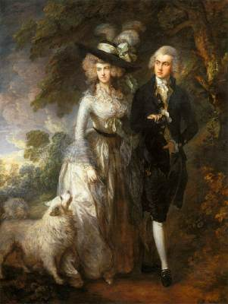

Gainsborough

Mr. and Mrs. William Hallett ('The Morning Walk')

1785
Oil on canvas, 236 x 179 cm

National Gallery, London

Instinctive, unpompous, drawn to music and the theatre more than to literature or history, and to nature more than to anything. 4)_______.
Suffolk-born, like Constable, he also became, within his means and times, a 'natural painter' - albeit of a very different kind. Although he said he wished nothing more than 'to take my Viol de Gamba and walk off to some sweet Village where I can paint Landskips', his feeling for nature encompassed much more than landscape. Children and animals, women and men, everything that dances, shimmers, breathes, whispers or sings, look natural in Gainsborough's enchanted world, so that 'nature' comes to encompass silks and gauzes, ostrich feathers and powdered hair as much as woods and ponds and butterflies. 5)_____________
In his early years in Sudbury, after his training in London restoring Dutch landscapes and working with a French engraver, Gainsborough's finish was less free. After moving to the resort town of Bath in about 1759, he found a metropolitan clientele, and discovered Van Dyck in country-house collections. 6)____________
In 1774 he moved permanently to London, where he built up a great portrait practice, but also began to paint imaginative 'fancy pictures' inspired by Murillo. He never aspired to 'history painting' in the Grand Manner. His poetry resides mainly in his brush, not in compositional inventiveness.
It was surely Gainsborough's own inclination, however, to interpret a formal marriage portrait, for which the sitters probably sat separately, as a parkland promenade. 7)____________
A Spitz dog paces at their side, right foot forward like theirs, as pale and fluffy as Mrs. Hallet is pale and gauzy. 5) ____________
The parkland is a painted backdrop, like those of Victorian photographers, yet it provides a pretext for depicting urban sitters in urban finery as if in the dappled light of a world fresh with dew.

After reading

1 Look at the following words and explain them in English.
natural painter, clientele, craftsman-painter, captivating the imagination, intercourse , the sitter, dispatch.
2 Fill in the appropriate word(s) from the list below. Use the word(s) only once.
Variety, metropolitan, feathers, Victorian, portrait, friendly, dispatches, true, inventiveness, fancy, parkland, painter, indiscriminate, effects.

Portrait _________________
_________________pictures
____________photographers
Prodigious_______________
the highlighted____________
marriage ________________.
_______________intercourse
_______________experimenter
__________________clientele
surface__________________
compositional ____________
ostrich _________________.
______________ promenade
__________________dignity

3 Complete the sentences, using the following phrasal verbs
To hold off, to hold apart, to hold down, to hold out, to hold back, to hold together, to hold on.
- They held the brawlers .
- I couldn’t hold him .
- Do you think you can hold the job________
- The rain held all morning.
- She held to the banisters.
- I can’t hold any hope.
- The box was held with string.

EXTRA TASK: Quotations

Comment on the sayings:
- All art is at once surface and symbol. It is the spectator, and not life, that art really mirrors. (Oscar Wilde. The picture of Dorian Grey. Preface)
- Painting is just another way of keeping a diary. (Pablo Picasso)
- The aim of art is to represent not the outward appearance of things, but their inward significance. (Aristotle)
- Art does not exist only to entertain, but also to challenge one to think, to provoke, even to disturb, in a constant search for truth. (Barbra Streisand)
- God and other artists are always a little obscure. (Oscar Wilde)
- Painting is a poetry that is seen rather than felt, and poetry is painting that is felt rather than seen. (Leonardo da Vinci)

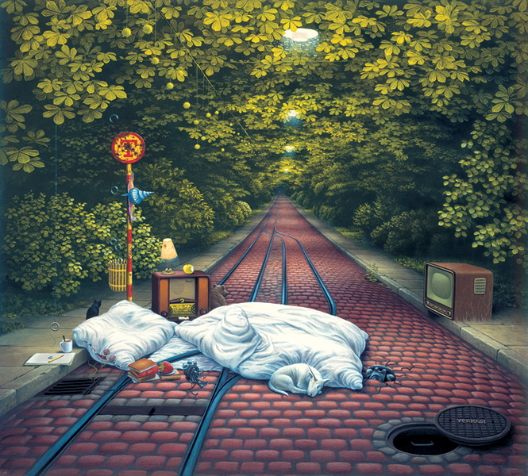
NB How to analyse an artist's work
Analysing an artist's work means studying the elements that make up an artwork. You can show your understanding by answering questions about the work.
The following headings and questions can help you to structure a piece of writing and understand a piece of artwork. Always remember to use your own words so that you are expressing what you think.

Form
This means looking at the formal elements of an artwork.
- What is the medium of the work?
- What colours does the artist use? Why? How is colour organised?
- What kind of shapes or forms can you find?
- What kind of marks or techniques does the artist use?
- What is the surface like?
- What kinds of textures can you see?
- How big is the work?

Context
This refers to how the work relates to a particular time, place, culture and society in which it was produced.
- When was it made? Where was it made? Who made it?
- Who was the work made for?
- What do you know about the artist?
- How does the work relate to other art of the time?
- Does the work relate to the social or political history of the time?
- Can you link it to other arts of the period, such as film, music or literature?
- Does the work relate to other areas of knowledge, such as science or geography?

Content
The content is the subject of a piece of work.
- What is it? What is it about? What is happening?
- Is it a portrait? A landscape? Abstract?
- What does the work represent?
- The title - what does the artist call the work?
- Does the title change the way we see the work?
- Is it a realistic depiction?
- Have any parts been exaggerated or distorted? If so, why?
- What is the theme of the work?
- What message does the work communicate?

Process
Looking at process means studying how the work was made and what techniques were used.
- What materials and tools were used to make the piece?
- What is the evidence for this?
- Do sketchbooks provide any clues as to how the work developed?

Mood
Mood means looking at how the artist has created a certain atmosphere or feeling.
- How does the work make you feel?
- Why do you think you feel like this?
- Does the colour, texture, form or theme of the work affect your mood?
- Does the work create an atmosphere?

UNIT 6
FEELINGS AND EMOTIONS

WARMING UP ACTIVITIES

I. They say, smiling can make you feel better. It is even more so with laughing. Read a short note from the BBC news web-site and give your comments. Would you like to try 'laughter yoga'?

Active Vocabulary
an enthusiast  to burst out laughing  a good laugh | a good guffaw  to trigger  feel-good effect

Laughter Yoga

Fitness enthusiasts in the Vietnamese capital Hanoi enjoy bursting out laughing as their early-morning exercise.

"A good laugh is equal to 10 prescriptions" or so the Vietnamese say. Fitness fans in Hanoi are hoping there is some truth to the saying as they take part in an early-morning 'laughter yoga' session. The combination of a good guffaw and exercise is said to stretch muscles and trigger endorphins - the chemical in the brain known for its feel-good effect.

Source: http://www.bbc.co.uk/russian/learning_english/2011/09/110928_witn_laughter_yoga.shtml
NB: You can also watch a video here.

CORE ACTIVITIES

ESSENTIAL COURSE TOOLKIT

A. SPEECH PATTERNS – FIELD STUDIES

Translate into Ukrainian, paying attention to the usage of the speech patterns. Pay attention to the fact that these sentences were taken from real life context.

1. How sneaky web developers use tricks of design to trick us out of money: Rhodri Marsden investigates the so-called 'dark patterns' (Monday 28 January 2013, The Independent, http://www.independent.co.uk)
2. Lady Catherine: Miss Bennet, I warn you, I am not to be trifled with. A report of a most alarming nature has reached me, that you intend to be united with my nephew, Mr. Darcy. I know this to be a scandalous falsehood, though not wishing to injure him by supposing it possible, I instantly set off to make my sentiments known. (Pride & Prejudice, movie script)
3. River Plate relegation riots give way to despair: Argentinian football supporters face up to most successful club sinking into second division for first time (http://www.guardian.co.uk)
4. And who are you, the proud lord said, that I must bow so low? (The Rains of Castamere, A Song of Ice and Fire series by George R. R. Martin)
5. The moment he laid eyes on you he knew: the only wish he wanted came true, he knows he's lucky that he met someone like you. (A Rocket to the Moon - Mr. Right, lyrics)
6. It’ll cost you Nothing to Dream & Everything NOT TO! (by a young artist named Rodney White who specializes in vintage graphic art)
7. Gallo is known for his outspoken views and generally sarcastic nature, once stating: "I stopped painting in 1990 at the peak of my success just to deny people my beautiful paintings; and I did it out of spite." (Vincent Gallo, an American film director, actor and musician)
8. DO YOU HAVE A BIRTHDAY THIS YEAR? Everyone has them. So why not use yours to do something meaningful? Give up your birthday gifts to raise money for clean water. (http://www.charitywater.org/)

B. LOOKING BEYOND THE TEXT

I. a) Have you ever wondered what happened at the end of the story between Lady and Napoleon? Did Napoleon read the letter? Or do you think that Lady managed to trick Napoleon out of it again? Read the ending of the story and say if your guess was true.
NAPOLEON (throwing down the letters in a heap on the table). Now. (He sits down at the table in the chair which he has just placed.)
LADY. Yes; but you know you have THE letter in your pocket. (He smiles; takes a letter from his pocket; and tosses it on the top of the heap. She holds it up and looks at him, saying) About Caesar's wife.
NAPOLEON. Caesar's wife is above suspicion. Burn it.
LADY (taking up the snuffers and holding the letter to the candle flame with it). I wonder would Caesar's wife be above suspicion if she saw us here together!
NAPOLEON (echoing her, with his elbows on the table and his cheeks on his hands, looking at the letter). I wonder! (The Strange Lady puts the letter down alight on the snuffers tray, and sits down beside Napoleon, in the same attitude, elbows on table, cheeks on hands, watching it burn. When it is burnt, they simultaneously turn their eyes and look at one another. The curtain steals down and hides them.)

b) Did you expect such an ending? Why do you think the story ended in this particular way?

C. ESSENTIAL VOCABULARY CHALLENGE

Study the additions to the essential vocabulary (p. 11-14). Do the following activities:
a) translate them into Ukrainian
b) explain them using English-English dictionary
c) make up a vocabulary story using them as key-words
d) explain the cultural allusions
e) comment on the proverbs
f) find your own synonyms, antonyms and other interesting additions to the vocabulary list

1. character
- to be in keeping with one’s character
- to form / mold one's character
- leading / main / major / principal character
- minor / supporting character
- Arabic character
- Cyrillic character
Usage example: to be full of character – to be individual in an interesting or unusual way
e.g. The island is full of character
Cultural allusion: J. T. Walsh and Dennis Hopper both made careers playing villainous characters. They are character actors. Character actor is an actor who specializes in playing eccentric or unusual people rather than leading roles
Cultural allusion: Character assassination is a deliberate and sustained process that aims to destroy the credibility and reputation of a person, institution, social group, or nation.
2. threat
- covert / implicit / veiled threat
- direct / explicit threat
- imminent threat
- threat to health
- to pose a major threat to something
- to receive death threats
- to come under threat
- to carry out a threat to do something
- to take the threat lightly
- to see something as a threat to something
Related items: warning, ultimatum; danger, peril, hazard, menace, risk
3. sink
- to sink in
- to sink without trace
- to sink something into
- to sink money or energy into something
- to sank into a coma
Usage example: to be sinking fast – to be approaching death
Idiom: a sinking feeling - an unpleasant feeling caused by the realization that something unpleasant or undesirable has happened or is about to happen
Slang: a sink - a school or estate situated in a socially deprived area
4. sense
- to sharpen the senses
- to dull the senses
- sixth sense
- a fine sense of comic timing
- a sense of right and wrong
- to make sense
- to sense a change
Usage example: sense of occasion - If there is a sense of occasion when a planned event takes place, people feel that something special and important is happening.
5. cautious
- to be a champion of a more cautious approach to something
- to be cautiously optimistic
- to exercise / use caution
- to sound a note of caution
Usage note: vigilant, careful, cautious, circumspect, wary, watchful, alert
All of these adjectives connote being on the lookout for danger or opportunity. Watchful is the most general term, meaning closely observant (a watchful young man who noticed everything). If you're vigilant, you are watchful for a purpose (to be vigilant in the presence of one's enemies), and wary suggests being on the lookout for treachery or trickery (wary of his neighbor's motives in offering to move the fence). If you're alert, you are quick to apprehend a danger, an opportunity, or an emergency (she was much more alert after a good night's sleep), and if you're careful, you may be able to avoid danger or error altogether. Cautious and circumspect also emphasize the avoidance of danger or unpleasant situations. To be circumspect is to be watchful in all directions and with regard to all possible consequences (these journalists have to be circumspect, not criticizing anyone too harshly); to be cautious is to guard against contingencies (a cautious approach to treating illness).
Slang: to be a real caution – to be an amusing or surprising person or thing
e.g. She's a real caution
6. slip
- standards have slipped
- to slip up
- to let something slip
- to slip through the net
- a slip dress
Euphemism: slip away - die peacefully
Usage example: to be slipping - to be behaving in a way that is not up to one's usual level of performance
e.g. You're slipping, Doyle - you need a holiday.
7. bitter
- bitter as wormwood
- bitter flavor
- bitter chocolate
- a bitter blow
Idiom: to the bitter end - used to say that one will continue doing something until it is finished, no matter what
e.g. the workers would fight to the bitter end for safer conditions
Cultural allusion: bitter - beer with a high hop content, with a slightly bitter taste
8. stir
- to be stirred to action
- to stir childhood memories
- to stir up anger
- to stir up trouble
- to stir the blood
Usage example: to stir from/out of - to leave or go out of (a place)
e.g. As he grew older, he seldom stirred from his club.
9. injure
- to be badly injured
- a look of injured pride
Related items: hurt, wound, damage, harm; cripple, lame, disable; maim, mutilate, deform, mangle, break
Derivatives: injurious - causing or likely to cause damage or harm
e.g. High temperature is injurious to mangoes
10. revenge
- in revenge
- to exact / get / have / take revenge (up)on smb.
- to give smb. his revenge
- out of revenge
- to take public revenge on somebody
Proverb: Revenge is a dish best served cold - vengeance is often more satisfying if it is not exacted immediately.

D. TOPICAL VOCABULARY UPDATE

І. Complete the sentences using words from the box:

confused drowsy faint fragile introspective listless
nostalgic peckish psyched up relieved tense

1. Tiredness can kill. If you start to feel ________ when you’re driving, stop as soon as you can.
2. It’s normal to feel a little bit ________ before a performance. But you have to get over it.
3. Anyone feeling ________ ? I’ve made a few sandwiches, and there’s tea or juice.
4. Oh, thank goodness you’re safe! I’m so ________ . I was imagining all sorts of horrors.
5. I someone feels ________ , get them to sit down straightaway as there is a danger of them falling. Stay with them, and offer them a drink of water.
6. She’s been ________ for weeks, just moping around the house. Is it a mood, or could it be something medical?
7. He’s been hurt a lot by the break-up. He’s a bit ________ at the moment, so treat him with care.
8. She’s a great coach. She manages to get the team ________ to just the right level before a game.
9. I’m ________ . It’s all too I don’t know. I don’t understand what’s happening to me.
10. She’s going through an ________ phase, trying to come to terms with herself. Her therapist is very helpful.
11. Times are hard for many Russians, and some feel ________ about the old soviet system.

E. PILOT PROJECT

Feelings and emotions are very important in our life. The most popular object of contemplation among ancient and modern writers is the feeling of love. One of the most famous among the world works of literature is Shakespeare’s play “Romeo and Juliet”.
- Read an abstract from this tragedy and define the metaphors used in it.
- Compare the original version of the text with the modern translation.

Act 1, Scene 5
 | Original Text | Modern Text
95 | ROMEO  (taking JULIET’s hand) If I profane with my unworthiest hand  This holy shrine, the gentle sin is this:  My lips, two blushing pilgrims, ready stand  To smooth that rough touch with a tender kiss. | ROMEO  (taking JULIET’s hand) Your hand is like a holy place that my hand is unworthy to visit. If you’re offended by the touch of my hand, my two lips are standing here like blushing pilgrims, ready to make things better with a kiss.
 | JULIET  Good pilgrim, you do wrong your hand too much,  Which mannerly devotion shows in this,  For saints have hands that pilgrims' hands do touch,  And palm to palm is holy palmers' kiss. | JULIET  Good pilgrim, you don’t give your hand enough credit. By holding my hand you show polite devotion. After all, pilgrims touch the hands of statues of saints. Holding one palm against another is like a kiss.
100 | ROMEO  Have not saints lips, and holy palmers too? | ROMEO  Don’t saints and pilgrims have lips too?
 | JULIET  Ay, pilgrim, lips that they must use in prayer. | JULIET  Yes, pilgrim—they have lips that they’re supposed to pray with.
 | ROMEO  O, then, dear saint, let lips do what hands do.  They pray; grant thou, lest faith turn to despair. | ROMEO  Well then, saint, let lips do what hands do. I’m praying for you to kiss me. Please grant my prayer so my faith doesn’t turn to despair.
 | JULIET  Saints do not move, though grant for prayers' sake. | JULIET  Saints don’t move, even when they grant prayers.
105 | ROMEO  Then move not, while my prayer’s effect I take. | ROMEO  Then don’t move while I act out my prayer.
 | Kisses her | He kisses her.
 | Thus from my lips, by thine, my sin is purged. | Now my sin has been taken from my lips by yours.
 | JULIET  Then have my lips the sin that they have took. | JULIET  Then do my lips now have the sin they took from yours?
110 | ROMEO  Sin from thy lips? O trespass sweetly urged!  Give me my sin again. | ROMEO  Sin from my lips? You encourage crime with your sweetness. Give me my sin back.
 | They kiss again | They kiss again

Source: http://nfs.sparknotes.com/romeojuliet/page_66.html

- What is a metaphor? Do you know that a metaphor is a great way for human beings to get to know themselves and their way of looking at the world. Think of other expressions used when speaking about love and kissing. What do they reveal to us about human attitude towards these subjects?
love
# deep love – глибоке кохання
# blind love – сліпе кохання
# to be in love with smb. – бути закоханим
# to be out of love with smb. – ненавидіти
# to fall in love / fall out of love – закохатись / охолонути
kiss
# fervent / passionate kiss – пристрасний поцілунок
# loving / tender kiss – ніжний поцілунок
# to throw a kiss – послати поцілунок рукою
# to snatch a kiss; to steal a kiss – зірвати поцілунок

- A beautiful image used in the text is the image of a pilgrim. A pilgrim is one who undertakes a religious journey or pilgrimage. Comment on this metaphor. Explain what feeling and emotions Romeo conveys through this metaphor.
- Read the information about “Juliet Club” in Verona and its activities taken from the official website (http://www.julietclub.com). Write your own letter to Juliet / Romeo.

“The Juliet club is a voluntary association. It has been active for many years, promoting the legend of Romeo and Juliet and the image of Verona, handling Juliet's correspondence and organizing some cultural events. Juliet's secretaries reply to thousands of letters pouring in from everywhere. They offer advice and support or they just listen to all those who feel the need to talk about love. Juliet's powerful guidance is a bridge spanning over all geographic and cultural distances.
The Club di Giulietta, our Verona-based organization that answers the thousands of letters addressed each year to Shakespeareґs most romantic heroine, awards the "Cara Giulietta" ("Dear Juliet") prize on Valentineґs Day to the most compelling letters received during the previous year. The "Dear Juliet" prize recognizes the spontaneity of the writers who turn to Juliet to express their feelings, ask for advice or simply feel closer to this universal symbol of eternal love. Write your letter.
CLUB DI GIULIETTA - THE JULIET CLUB
via Galilei 3 - 37100 Verona
Tel: (+39) 045 533115
info@julietclub.com.”

EXTRA TOOLS

I. For many families autism is a serious problem, which can prevent them from enjoying their children’s development. But parents do not give up. Autism is not the final verdict. Read the text below and prepare a short summary. Do the test under the text.

Active Vocabulary
to respond to emotions  to process voices and emotions  autism | fundamentally  to advance understanding  infant development

Babies can 'hear' emotion as early as three months old

Babies can respond to emotions in a human voice at just three months old - earlier than previously thought - researchers believe. The results of scans on 21 sleeping babies suggested the brain responded to the type of sounds being played. Researchers said it had previously been unclear when human brains developed the ability to process voices and emotions.
Scientists hope to learn the difference between the way autistic and non-autisitc brains develop as a result. They used functional magnetic-resonance imaging (fMRI) to record how babies responded to tapes playing "emotional sounds", such as laughing and crying, as well as background noises, like water or toys. A part of the brain - the temporal cortex - was activated when human voices were played - the same region as in adults.
Professor Declan Murphy, from King's College London, said: "This discovery fundamentally advances our understanding of infant development." Dr Evelyne Mercure, of University College London, said: "It is a rare demonstration that specialised areas exist in the brain very early in development." The researchers hope the study will allow them to compare what happens in autistic and non-autistic brains. Professor Murphy told the BBC: "By identifying when brain systems come on stream, we can understand where it goes wrong." The researchers are also scanning the brains of babies thought to be at risk of developing autism, such as those who have a sibling with the condition. They are investigating when differences can be detected.

1. What can babies do at the age of three months?
A. They can understand the words
B. They can respond to the different types of sounds
C. They can react to the different types of music

2. Why is this experiment so important?
A. It can help cure the autistic children
B. It can help make babies sleep better
C. It can provide us with new knowledge about feelings and emotions

3. How was the experiment conducted?
A. The babies and the adults had to listen to some music and “emotional sounds” and the results were later compared
B. The sleeping babies were to listen to different kinds of “emotional sounds”
C. The babies produced “emotional sounds”, such as laughing and crying, and the scientists recorded them

4. What is “the temporal cortex”?
A. A zone in the brain
B. A temporal state of the brain
C. A type of medicine used in the experiment

5. Is there any similarity between the reactions of the infant and adult brains?
A. No, adult brain reacts faster
B. It is not clear from the results of the experiment
C. Yes, the same regions are activated

6. What does Dr Evelyne Mercure, of University College London, say about the experiment?
A. This experiment is a great achievement and a new step in the development of science
B. This experiment has proved that the brain starts to develop quite early
C. This experiment has shown that autistic children start to develop earlier than their siblings

7. What is the main result of this research?
A. It can help the scientists understand what is wrong with the method of functional magnetic-resonance imaging (fMRI)
B. It can show the difference between the infant and the adult brains
C. It can provide the scientists with the data about the development of the autistic children

II. Lovesickness can kill and should be taken more seriously as a legitimate diagnosis, according to health experts. Read the text below and prepare a short summary. Do the test under the text. Do you think that love is a disease?

Active Vocabulary
to experience lovesickness  unrequited love  to fall in love  to suffer  to be aware of smth | a broken heart  an extreme state of physical exhaustion  an elevated mood  inflated self-esteem  insomnia

British study says: Unrequited love can be a 'killer'
Frank Tallis, a clinical psychologist in London, is among those calling for greater awareness of the "illness" in a report in The Psychologist magazine. He said many are "destabilised by falling in love, or suffer on account of their love being unrequited" and this could lead to a suicide attempt. Few studies deal with the "specific problem of lovesickness", he said.
Prof Alex Gardner, a clinical psychologist in Glasgow and a member of the British Psychological Society, agreed that doctors needed to be more aware of lovesickness as a possible diagnosis. He said: "People can die from a broken heart. You get into a state of despair and hopelessness." He said as a result of love, in some people it could lead to an extreme state of physical exhaustion. In extreme cases lovesickness could drive people to take their own life, he added.
Dr Tallis said that before the 18th Century lovesickness had been accepted as a natural state of mind for thousands of years. He said in modern day terms the symptoms can include mania, such as an elevated mood and inflated self-esteem, or depression, revealing itself as tearfulness and insomnia. Aspects of obsessive compulsive disorder can also be found in those experiencing lovesickness, such as preoccupation and obsessively checking for text messages and e-mails.
Source: http://www.bbc.co.uk/worldservice/learningenglish/newsenglish/britain/love_sickness.shtml
1. What do the experts say about love nowadays?
a) It is a serious disease that can be fatal.
b) Before the 18th century people loved stronger.
c) Love should be treated clinically in special hospitals of the British Psychological Society.

2. Is the specific problem of lovesickness thoroughly studied?
a) Yes, there are many studies on this problem.
b) Yes, there are some studies on this problem.
c) No, there are not enough studies on this problem.

3. According to the text, what can be the effect of unrequited love in extreme cases?
a) a suicide attempt
b) a serious illness
c) change of occupation

4. People suffer because
a) they fall in love
b) their heart is broken
c) their lovers commit suicide

5. What changed in the 18th Century?
a) The symptoms of lovesickness got more serious and acute.
b) Love started to be perceived as a disease.
c) Lovers started sending each other text messages and e-mails.

6. What is one of the main symptoms of lovesickness?
a) Sleeplessness
b) Constant hunger
c) Greater awareness of being sick

7. What is one of the rituals, characteristic of people who are lovesick?
a) waiting for messages
b) writing new messages
c) correcting mistakes in their own messages

SELF-STUDY ACTIVITIES

Text 14: YOUR TEMPER ACCORDING TO YOUR HOROSCOPE

Pre-reading:
- Do you believe in horoscopes?
- What is your sign of the Zodiac? What features of character are typical for your sign? Do you possess these features?
- What features of character do you like in people?

While reading:
- Explain the meaning of the following words:
decorum, vindictive, seductive charm, fumble for words, tantrum, haughtiness, tongue-lashing, frustration.
- Put the paragraphs of the text according to the order of the succession of Zodiac signs.

Now read the text and do the exercises.

Your temper according to your horoscope

SCORPIO (OCTOBER 23, NOVEMBER 21)
Of course you don't lose your cool. But your very demeanor (manner) projects haughtiness, pride and grand disdain (disregard) for lesser mortals (human). Others are often found saying that anger sits on your nose and you are raring to give your piece of mind to the first person who try to be funny with you. You are selective in the choice of your friends, and have a low tolerance for the superfluous (extra) types. Your tongue-lashing (attack) is generally in a soft hissing tone for when you scream, your voice tends to get shrill and loud and you do hate drawing attention to yourself! When upset, you are angrier with yourself for having shown weakness, for the last thing that Scorpio wants to show is being out of control.

TAURUS (APRIL 2, MAY 20)
You are generally quiet and have control over your emotions. It is difficult to predict what will upset you, so when you do lose your cool, people don't know how to react. Your temper is like that of a raging bull, and anyone trying to pacify you will be the first one to get a verbal bashing. You generally get upset when you are concerned or when people accuse you of doing something wrong. You also hate being reminded about mistakes you've made in the past. You also have the potential to be terribly vindictive if rubbed the wrong way.

AQUARIUS (JANUARY 20, FEBRUARY 18)
You are noble and kind and dislike losing control over your emotions. It is very rare for you to get angry. You are also the pacifier in situations that involve arguments. It is always your endeavor to be perfect and socially correct in your behavior and attitude, but if misunderstood and slighted you can give in to an angry outburst. You will shout and scream and then walk out from the scene. You cannot easily forget the situation and will be bitter about it for a long time.

CANCER (JUNE 21, JULY 21)
Considering how charming, caring and kind you are, you dislike unpleasant scenes, much less creating one yourself. You have great tolerance and rarely get provoked into losing your temper. If someone is unreasonable or trying to create trouble, you are more likely to walk away quietly. But that does not mean you do not have a temper. When angry, in your effort to control your emotions, you tremble, your hands get sweaty and sometimes you fumble for words. Tears roll down your eyes easily and the opponent is touched by your innocence and will seek an apology immediately.

SAGITTARIUS (NOVEMBER 22, DECEMBER 20)
You are insensible and generally have no complete control over your emotions. You do get angry quickly and others marvel at your anger levels even when provoked. Actually, you get tongue-tied when angry and you will remove your anger waiting for the other person to calm down. Then you will reason with your opponent and convince the other person in a very gentle manner that the whole thing was just his mistake. You're also likely to totally sever ties with someone when you're upset with them.

LEO (JULY 22, AUGUST 21)
If anyone has total control over their emotions, it is you. But then, you can be described as stiff, cold and uncaring. You are known to lack spontaneity but you really don't care about opinions. You don't like to create scenes and will never accept invitations to a party where you suspect the presence of an unruly lot. But your very presence seems challenging to some and they take vicarious pleasure in your disquiet. When angry you can use critical language. A dressing down can humiliate your opponent, causing a strain between both of you forever.

VIRGO (AUGUST 22, SEPTEMBER 21)
Most of you are gentle and have full control over your emotions but those of you given to temper tantrums can certainly get violent. When see things with rage, you yell and shout and tend to break things lying close at hand. You can even harm yourself by banging your hands on a glass top table or wall. You should never get into any argument, for you are a sore loser. You feel that others are trying to persecute you and don't quite respect your opinions. When hurt, you can also hold grudges forever.

ARIES (MARCH 21, APRIL 20)
Nothing seems to ruffle you more than a lack of discipline, disloyalty and decorum. But Arians are also known to go into a rage very easily when challenged. Those of you who have been on the receiving end of the Aries temper know that if not calmed down they can even get violent. But one thing is certain if the opponent remains calm and does not react to their outburst, Arians cool down very fast. They are also the first to apologize, which makes them easier to forgive.

LIBRA (SEPTEMBER 22, OCTOBER 22)
Did someone say that you are the charmers of the zodiac? Well, it's true. Few have ever seen you ruffled or angry. You are very conscious of your image, and you believe that anger distorts your face and personality. You also think you are above things like anger. But wait before you get into self-congratulatory mood. Your family or those very close to you know you better. You have an unmatched temper amongst all the zodiac signs, and what makes it worse is your capacity to justify it.

GEMINI (MAY 21, June 29)
You are recognized by your cheerful disposition and your jovial nature is easily susceptible to anger. In fact, you are the best person to have around when there is an ugly scene at a party you can bring the warring factions together quite diplomatically. But when you lose cool, you yell and scream and will not listen to reason. You must have the last word in a wordy duel. Your capacity to argue aggressively is matched only by your seductive charm.

CAPRICORN (DECEMBER 21, JANUARY 19)
Few will believe that a hardcore practical and materialistic person like you is capable of sensitivity and genuine emotions. You project a hard exterior but are actually very sensitive, a trait you successfully hide from others. You can see thing with anger but will not betray your feelings. But then, there are times that even you cannot control your temper. Under such circumstances you can shout and scream, more with frustration at the situation than with anger at any particular person. Your outbursts can shock others and can make them feel guilty too.

PISCES (FEBRUARY 19, MARCH 20)
The only thing that can be said about you dreamers is that you appear even more attractive when angry. You are very sensitive to others' feelings, so you rarely hurt them. But when others tend to hurt you, then things take a nasty turn. You will yell and use harsh words and feel inclined to shake everything and everyone up. Your creative imagination is at its best when angry, and you tend to get pretty dramatic. When upset, you refuse to listen to reason and wish to be left alone. But once you calm down, you repent your tantrums and seek forgiveness. SO nobody can be upset with you for too long.

After reading

1. Find Ukrainian equivalents for the following words: harsh words, repent the tantrums, cheerful disposition, wordy duel, pacifier in situations, endeavor, grand disdain, hold grudges forever, rub the wrong way.

2. Match words with their translation:
- sit about a. Спостерігати, бути присутнім, брати участь у чомусь в якості спостерігача
- sit back b. Всаджуватися, займати місце
- sit down c. Сидіти без діла
- sit in d. Не брати участь (зазвичай у танцях)
- sit out e. Сидіти терпляче до кінця чогось
- sit through f. Засиджуватися до пізньої ночі
- sit up g. Розслаблятися, відкидатися на спинку стільця

3. Fill in the blanks with the words given above.
- Sit _____________, there's no need to be nervous.
- Please come in and sit _______________.
- It's lucky for some people, who can sit_____________ with nothing to do.
- The unexpected news made him sit _____________.
- I think I'll sit________________ the next dance, I'm tired.
- The public may sit _______________on all council meetings.
- Jane's parents sat _____________ the first part of the school concert, waiting to hear their daughter sing.
- Mother, please don't sit____________ for me.

4. Read the proverbs and sayings. What proverb do you like the best? Why?

- Benjamin Disraeli -“Characters do not change. Opinions alter, but characters are only developed.”
- Jean Paul Richter - “A man never shows his own character so plainly as by his manner of portraying another's.”
“Character develops itself in the stream of life.”
- John Holt - “The true test of character is not how much we know how to do, but how we behave when we don't know what to do.”
“Reputation is what the world thinks a man is; character is what he really is.”
“Character is a victory, not a gift.”
“Character is a diamond that scratches every other stone.”
“You can tell what a man is by what he does when he hasn’t anything to do.”

Text 15: EMOTIONS

Pre-reading:

Answer the questions:
1. In what way are emotions connected with mental activity?
2. Into what two large groups can we divide emotions?
3. Can we consciously choose our emotion responses?

While reading:

Fill in the missing sentences
- The concept governs the use of will.
- But more often than not we act subconsciously.
- No single emotional response can be permanent.
- We put a value on emotional experience.
- Emotions are partly derived from feelings.
- The way that we dislike it may focus on fear, hate or self-pity.

Now read the text and do the exercises.

The peculiarity of any particular emotion is that, whilst it is just an emotion, it is nevertheless intimately associated with specific mental attitudes and ideas that have become characteristic of that emotion. In general, scientists found that each emotion acts as a nucleus for pre-set ideas about the world. This fact gives rise to a notable phenomenon. As one emotion fades away and the next one is generated, so the ideas in a person’s mind automatically change: the fresh emotion brings with it its associated ideas.
A person is always experiencing some emotion at any time, since when the present emotion fades away so another emotion will take its place and be felt by him / her. 1)_________ When any emotion, such as anger, is experienced the person can stay angry only for some time; eventually the anger will fade away and a fresh emotion will arise.
There are just three feelings: the pleasant one, the unpleasant one, and the neutral one. This is the Buddhist understanding and scientists verified this fact directly during the time when they used to practice meditation. In the past, some moral theorists believed that the neutral feeling is only an equal mixture of both pleasant and unpleasant feelings, so that the net effect is zero. But meditational awareness disproves this assumption.
2)__________ To explain how this derivation occurs scientists use a model of consciousness that is a traditional one: consciousness has three models, those of will, mind, and feeling. Past variations on this model substituted action for will, and emotion or sensibility for feelings. In this model scientists distinguish between consciousness and mind. Consciousness is the totality of the person, whilst mind is only one feature of it.
Mind is the key to consciousness. Mind, in fact, is the ‘cement’ that keeps all aspects of consciousness together.
Now the mind helps to produce desires and emotions. In this aspect of mind we use ideas or concepts.
Will is a pure striving, an undirected effort. When will is united with mind, it generates desire. Desire is the activity of will directed into a mental concept.3)______________ The concept directs the will.
When feeling is united with mind, it generates emotion. Emotion is the activity of feeling directed into a mental concept. The feeling energizes a conceptual response to a stimulus. Feelings are primarily either pleasant or unpleasant; rarely are they neutral. Hence there are two possible conceptual responses to any stimulus, which in turn leads to two possible emotional responses. 4)_________By either liking or disliking things, relationships, situations, etc we put a value on them. At any particular moment we may either like or dislike something; but this liking and disliking can take many forms. For example, the way that we like that something may lead us to choose between anger, love or vanity as our response. Anger allows us to dominate the situation; love enables us to harmonize with other people; vanity lets us feel important. 5)_____
So at any particular moment we are focusing on a trend of thought, with a relevant emotion being experienced. Then there is some change in the situation that needs an emotional response from us. Sometimes we can consciously choose our response, particularly if the situation is a pleasant one.6)_______ The value that we place on the situation at that moment determines which emotion will be felt. For example, if we are feeling discontented, we will place little positive value on our present experience; then when we have to respond to something we are more likely to choose some form of hostile or fearful response.
In general, the definition of an emotion is that it is an unconscious idea powered by either a pleasant or an unpleasant feeling.

After reading

1. Fill in the prepositions
1. response ________a stimulus;
2. to choose _________ anger, love or vanity;
3. to focus ________fear;
4. to need response ________ us;
5. to place value________ experience;
6. to respond__________ something;
7. a nucleus __________ pre-set ideas;
8. to give rise____________;
9. to fade___________.

2. Give synonyms to the following words. Use some of them in the sentences of your own.
Peculiarity, particular, to be associated, attitude, notable, to fade away, to generate, awareness.

3. Find out all the meanings of the following phrasal verbs, use them in the sentences of your own
To lead, to let, to change, to choose

Text 16: FEELINGS AND EMOTIONS

Pre-reading:
- Do you consider yourself an emotional person? Do you believe that certain feelings and emotions can influence our everyday life?
- Do you think people that try to avoid negative emotions are more successful?
- Why it is so important to think positively, for you personally?

While reading:

1. Explain the meaning of some words from the text:
To insure, an auto-suggestion, to constitute, “cold reason”, to hand over, to transmute, “inner audience”, to heed.

2. Now read the text and do the exercises.

The subconscious mind is more susceptible to influence by impulses of thought mixed with "feeling" or emotion, than by those originating solely in the reasoning portion of the mind. In fact, there is much evidence to support the theory, that ONLY emotionalized thoughts have any ACTION influence upon the subconscious mind.
It is a well known fact that emotion or feeling, rules the majority of people. If it is true that the subconscious mind responds more quickly to, and is influenced more readily by thought impulses which are well mixed with emotion, it is essential to become familiar with the more important of the emotions. There are seven major positive emotions, and seven major negative emotions. The negatives voluntarily inject themselves into the thought impulses, which insure passage into the subconscious mind. The positives must be injected, through the principle of auto-suggestion, into the thought impulses which an individual wishes to pass on to his subconscious mind.
These emotions, or feeling impulses, may be likened to yeast in a loaf of bread, because they constitute the ACTION element, which transforms thought impulses from the passive to the active state. Thus may one understand why thought impulses, which have been well mixed with emotion, are acted upon more readily than thought impulses originating in "cold reason."
You are preparing yourself to influence and control the "inner audience" of your subconscious mind, in order to hand over to it the DESIRE for money, which you wish transmuted into its monetary equivalent. It is essential, therefore, that you understand the method of approach to this "inner audience." You must speak its language, or it will not heed your call. It understands best the language of emotion or feeling. Let us, therefore describe here the seven major positive emotions, and the seven major negative emotions, so that you may draw upon the positives, and avoid the negatives, when giving instructions to your subconscious mind.

SEVEN MAJOR POSITIVE EMOTIONS
The emotion of DESIRE
The emotion of FAITH
The emotion of LOVE
The emotion of SEX
The emotion of ENTHUSIASM
The emotion of ROMANCE
The emotion of HOPE
SEVEN MAJOR NEGATIVE EMOTIONS (To be avoided)
The emotion of FEAR
The emotion of JEALOUSY
The emotion of HATRED
The emotion of REVENGE
The emotion of GREED
The emotion of SUPERSTITION
The emotion of ANGER
Think and Grow Rich
After reading

1. Find the Ukrainian equivalents. Use at least five or these phrases in the sentences of your own.
to be susceptible to, originating solely, voluntarily, the passage into subconscious mind, the principle of auto-suggestion, to be likened to, monetary equivalent.

2. Fill in the blanks:
to draw in, to draw on, to draw from, to draw aside, to draw up, to draw back, to draw out, to draw after, to draw down, to draw away, to draw off
- She drew her inspiration _____________ her childhood.
- Drawing the curtain _____________, he looked down into the street.
- The book starts slowly, but it gradually draws you _____________.
- He’s very shy and needs to be drawn _____________.
- She agreed to draw ____________ a proper contract.
- Night was drawing ____________.
- This act drew___________ it important consequences.
- The crowd cheered as the ship drew slowly ____________.
- Don't risk drawing____________ his anger.
- Help me to draw ________________ these muddy boots.
- The crowd drew ________________to let the firemen through.

3. Answer the question and explain the reasons
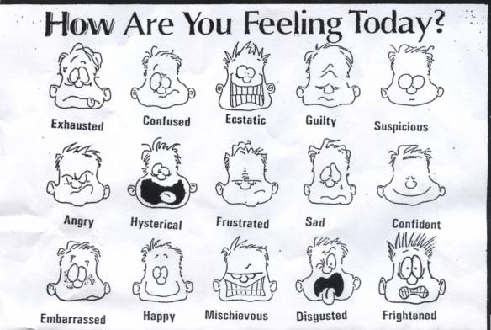

4. Comment on the quote
When we learn to manage our emotions long enough to stop and shift our attention to the quieter message of the heart, we can gain a wider perspective on any situation, often saving ourselves from hurt, frustration and pain.
(Doc Childre and Howard Martin, The HeartMath Solution)

NB Types of Essays

The construction pattern for your essay may depend on the type of essay you are writing. Discover essay types and find tips for improving your essay flow.

Writing an Opinion Essay
You may be compelled or required to write an essay that is based on your own personal opinion about a controversial topic. Depending on your objective, your composition could be any length, from a short letter to the editor, to a medium-sized speech, or a long research paper. But every piece should contain some basic steps and elements.

How to Write a Process or "How-To" Essay
How-to essays are like recipes; they provide instruction for carrying out a procedure or task. You can write a how-to essay about any procedure that you find interesting—as long as your topic fits the teacher’s assignment.

Compare and Contrast Essay
Compare and contrast essays may be constructed in one of two ways. You can focus on one topic at a time, describing the pros and cons of one topic first and then moving on to the next topic. Before you begin to draft a compare and contrast essay, you should brainstorm to list similarities and differences.

How to Write an Argument Essay
For an argument essay to be effective, it must contain certain elements. For this reason, you'll have to plan ahead a little. Take a few minutes to prepare before you jump into writing an argument essay.

Expository Essays
Expository essays are simply essays that explain something with facts, as opposed to opinion. An expository essay should have the same basic structure as any typical essay.

Types of Essays
What type of essay should you write? That can depend on your interests and strengths. Are you persuasive, or are you gifted with great descriptive powers? Find an essay type to fit your own special personality.

How to Write a Response Paper
A response paper, sometimes called a reaction paper, is much like a formal article or review, but this type of assignment calls for more of the writer's personal reaction and feeling.

How to Write a Film Review
The film review should include several standard components. The order and composition of your review will depend on the class and your instructor.

How to Write Your Autobiography
If you think your life is too boring to write about, think again! This article will help you identify the most interesting elements of your life experience and turn them into a story others will enjoy reading.

Study the essay structure

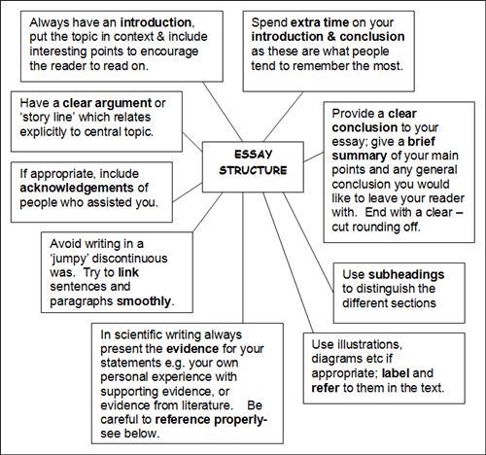

Text 17: THE WORLD OF FEELINGS AND EMOTIONS

Pre-reading:
- What influences your fееling of happiness?
- Can we control our emotions?
- Do we imitate our parents’ behavior when we become adults?

While reading:

1. You are going to read an article about feelings and emotions. Choose a sentence from the list below which gives the best fit to each part:
- Unfortunately, we cannot simply decide that from now on we will be happy and loving.
- It needs either willpower and determination or the help of good friends.
- As a result we feel resentment, hopelessness, depression, perhaps also anger and hatred.
- We became programmed by observing and imitating our role models.
- It is not sufficient trying to believe that we will be happy ever after.
- Our emotions are conditioned by our beliefs.

2. Now read the text and do the exercises.

Happiness, joy and love are not caused by events but by our attitude. We can learn to choose how we want to feel. Why not choose love and joy?

by Walter Last
We all would like to live a happy, healthy and fulfilled life, yet few seem to be able to do just that. Why must we have so much suffering, failures and disappointments? We just want to be secure in a loving relationship and a satisfying job with a good income and enjoy ourselves.
Instead, our relationships turn sour all too soon, we have a job that we do not like or we do not have one at all, there is never enough money and generally there is not much joy to be found anywhere1) _____________ Where and why did it all go wrong?
I believe that there is a way out of this depressing jungle of negativity and disappointments. I actually believe that we can make a decision to have a happy, fulfilled life and then really do it. What I cannot promise is that it will be easy2)____________ But you have nothing to lose by trying and each step in the right direction is likely to bring some reward.
We can be happy or at least accepting in adversity and unhappy when we seem to have everything. What decides how we will react and how we will feel inside? It is no secret to psychologists that we are programmed since earliest childhood by everything that went on around us, but especially by the way our parents talked to us and to each other, by the way they felt and reacted and by the interactions with our siblings3)______________
If we were lucky and grew up in a happy and loving family, we probably have an inner program that makes it easy for us to lead a happy life in a loving relationship. If, on the other hand, there was much worry, anger, resentment and other negativity in our childhood, chances are that we will have a hard time being happy and loving as adults. That probably applies to most of us; we are victims of negative programming, during childhood.
If we really want to change, there is only one thing to do: we must change our subconscious programming from a negative outlook on life to a positive one 4)___________Such conscious decisions on their own have little influence on our subconscious programming. In fact, if there is a conflict between our subconscious programming and our conscious will, the subconscious will always win.
Therefore, we must be clever and beat the subconscious at its own game. We must throw the old program out and devise a new one that allows us to be as we really want to be. However, it is not sufficient just to work with our feelings and emotions because these do not arise out of a vacuum 5)_____________ We react more to our beliefs than to facts or anything else. Therefore, we must adopt an appropriate belief system.
Where do we find the beliefs we want? (6) _____________ Our proposed new beliefs must be believable to be acceptable to both, our conscious and our subconscious mind. It must be something that gives meaning to our life that makes sense of it all. Meaning is the opposite to the inner emptiness that many of us try to fill with pleasure seeking and power games, causing so much emotional trouble in the end and depression if we fail. My solution is a spiritual philosophy of life that turns emptiness into meaning.
In addition, there is also a strong influence of physical factors on our emotional life, such as nutrition and tense muscle structures. Therefore, in order to heal our emotions properly, we must work on all four levels of our being, the biological, the emotional, the mental and the spiritual level.

After reading

1. Find the Ukrainian equivalents of the italicized words from the text.

2. Complete the sentences using the words in bold:
grow down, grow on, grow up, grow into, grow over, grow from, grow out

- Even if you plant the seed upside down, the roots will still____________.
- Most international firms _____________ small family businesses.
- When we returned from our holidays, the whole garden was ____________with wide leaves and long roots.
- You need time______________ a new job.
- Jane is _____________so fast, I think she’s going to be a tall woman.
- Habit ____________ a person.
- The children ____________ of their clothes.

3. Make the sentences with the word combinations givеn below: to turn yellow, to turn out in the cold, to turn the scale, to turn up one’s heels, turn loose.

4. Look at the synonyms, given below. Explain the difference in their meaning.
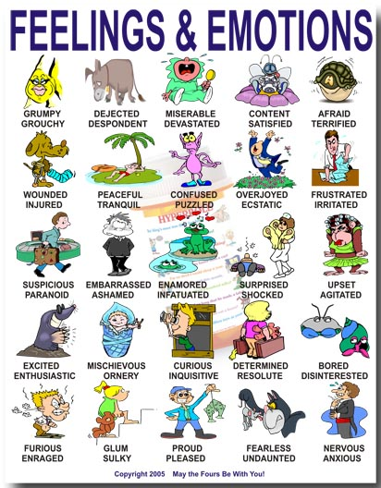

- Explain the meaning of these quotations:

- “I don't want to be at the mercy of my emotions. I want to use them, to enjoy them, and to dominate them.” (Oscar Wilde, The Picture of Dorian Gray)
- “One thing you can't hide - is when you're crippled inside.” (John Lennon)
- “All the knowledge I possess everyone else can acquire, but my heart is all my own.” (Johann Wolfgang von Goethe)
- “Do you imagine the universe is agitated? Go into the desert at night and look at the stars. This practice should answer the question.” (Lao Tzu)
- “Life is a comedy to those who think, a tragedy to those who feel.” (Jean Racine)
- “For me, living means I can be responsive to the other person. It means I can show my emotions and my feelings. Talk to them. Feel with them …” (Morrie Schwartz)

