HOMEWORK 1. WORKING WITH THE FOREIGN SOURCES
Task 1 Which of the graphs are graphs of function of x, and which are not. Give reasons for your answers
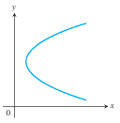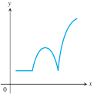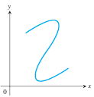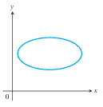
A B C D

Task 2 Read the text «Solution by Cramer’s rule» using the following link. Classify the terms according to the classification from the theory. Write 4-5 sentences using these terms
https://uomus.edu.iq/img/lectures21/MUCLecture_2024_4519375.pdf

Task 3 Open the link https://www.geogebra.org/, choose one of the proposed resources, complete the test, and get ready to answer the questions, connected with the terminology
The task is interactive. It involves navigating an English-language information resource, which can be accessed at https://www.geogebra.org/. To complete this task, we suggest the following plan:
- select one of the resources from the “Resources” window;
- select material for which tasks are graded on a scale of 9-12 points;
- read the explanations and complete the proposed tasks;
- when defending your task, demonstrate the correct use of mathematical terms;
- in the report, provide several scans of the test tasks you have completed after they have been checked.
Pay special attention to the construction of terminological phrases.
Task 4 Follow the example
1)
2)
3)
4)

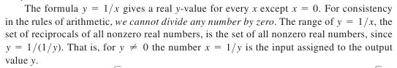
Task 5 Find the articles on the irreducible polynomials in English using internet. Answer the following questions:
- How can we test polynomial for irreducibility?
- Formulate Eisenstein criterion.
Give the examples of the irreducible polynomials of 2, 3, 4 degree.

Task 6 Select the articles in a foreign language on the topic of the qualification thesis, using key words. Make a list of articles according Національний стандарт України ДСТУ 8302:2015. Read and translate selected articles for your qualification thesis.

Task 7 Read the article at the link
https://fmo-journal.org/index.php/fmo/article/view/411/263
Write a summary and an abstract.

