Завдання для практичних занять 8-9
My future profession

- What are your three most important conclusions from the following picture?

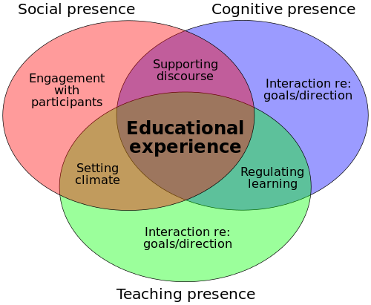
- How do you view your own role as teacher in high school? What is important to you? What kind of teacher do you want to be?

- How do YOU motivate your students?

- What are your three most important conclusions from the following information?
Some facts about memory
- Students capture only 20-40 percent of a lecture's main ideas in their notes.
- After three weeks, most students recall less than 10 percent of what was said in the lecture.
- A lecturer says 100-200 words a minute, and a student hears 50-100.
- In a typical lecture class, students are attentive just 40 percent of the time.

- Should a lecture be interactive? Explain why.

- Do you know “the rule of six” for presentations (for reports, distance learning, etc.)?

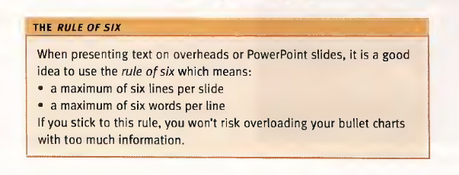

- Can you explain following “ladder”?
Create
Generate hypotheses, plan and execute something new, actualize
Evaluate
Evaluate, critically review using appropriate criteria
Analyse
Identify and extract central issues/relevant information, structure, separate fact from assumption, derive
Apply
Methodological approach, apply method to new challenges/problems
Understand
Interpret, translate, exemplify, classify, draw conclusions, compare, explain
Remember
Describe, define, name, list, pull out of long-term memory

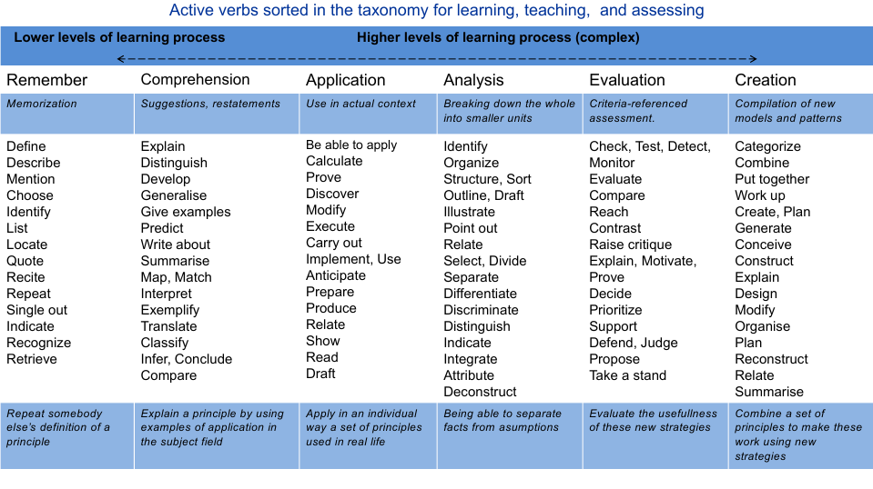

- Flipped-classroom approach. Do you have any thought on using a “flipped classroom” approach in your future teaching?
- Problem-Based Learning activities
“At first I made discoveries known to everyone, than – known to a few and finally unknown to anyone” (K.Tsiolkovsky)
- Types of assessment
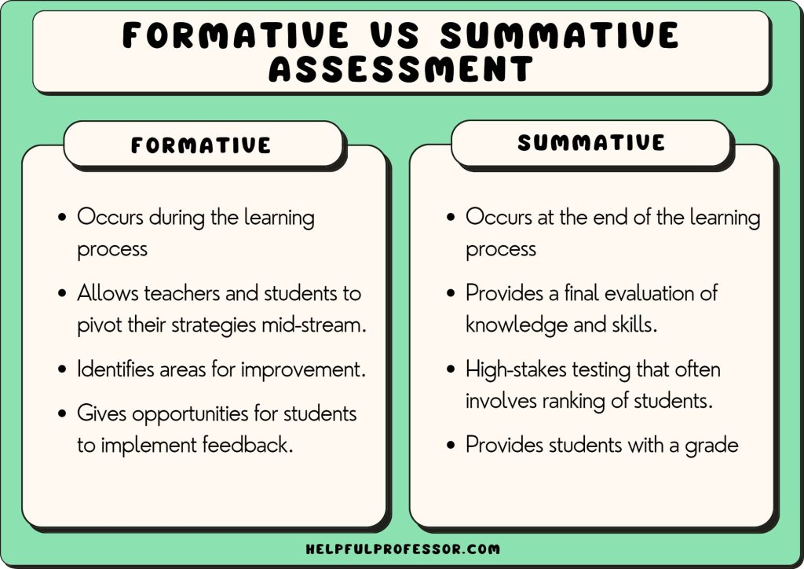

The classroom formative assessments:
1) The Background Knowledge Probe and Focused Listing when the students categorize skills into classes;
2) Problem Recognition Tasks and Problem-solving activities when the students solve problem in the Breakout Rooms and perform activity 3;
3) Skills Checklists when the speakers from each group do their mini-reports, other students comment or ask questions;
4) Feedback on the task when the students do interactive activity 3;
5) Feedback on the process when the students build a “questions ladder” in line with a “cognitive level ladder” (interactive activity 4);

Prioritizing – what is important when it comes to assessing student knowledge and skills? (rank the three that you feel most important to you, from 1 – 3.)
__ 1. Oral presentation skills
__ 2. Individual work and product
__ 3. Group work and product
__ 4. Peer feedback
__ 5. Written assessment – minor report
__ 6. Written assessment – larger (invigilated)
Something else:
__ 7. ________________________________________________
__ 8. ________________________________________________
- Techniques of feedback

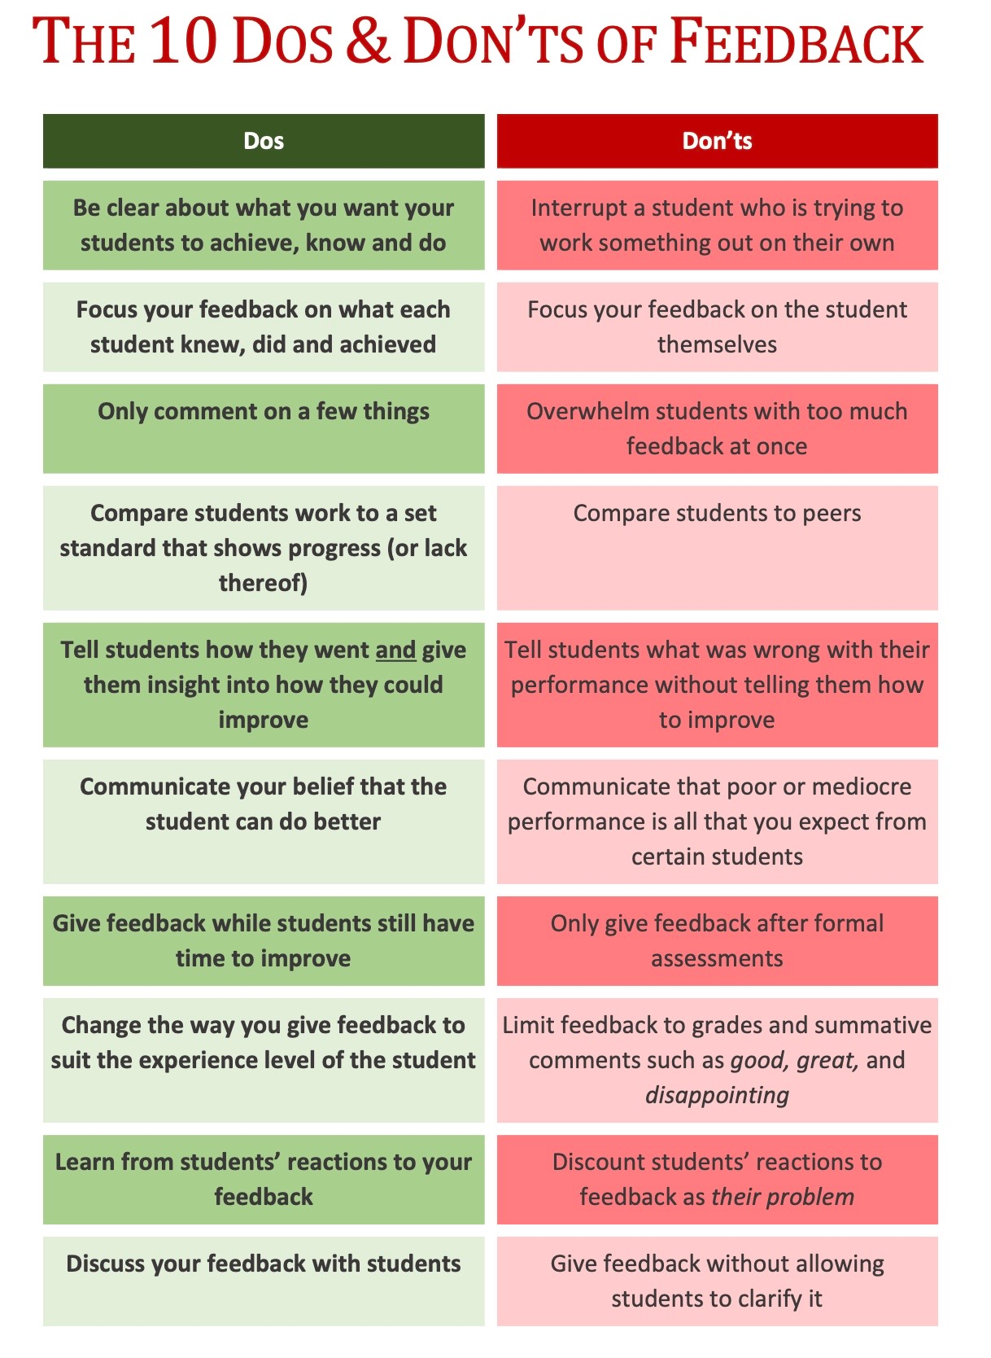

I found more feedback traps from other resources:
- “Everything is so clear, we are adults”;
- “Successes are already visible, it is necessary to focus on eliminating mistakes”;
- “Only positivity and praise is motivating, isn’t it?”;
- “Let’s talk about everything at once, so as not to gather twice”.

