Homework 2
Working with foreign sources
Task 1. Open the link https://www.geogebra.org/, choose one of the proposed resources, complete the test, and get ready to answer the questions, connected with the terminology
The task is interactive. It involves navigating an English-language information resource, which can be accessed at https://www.geogebra.org/. To complete this task, we suggest the following plan:
- select one of the resources from the “Resources” window;
- select material for which tasks are graded on a scale of 9-12 points;
- read the explanations and complete the proposed tasks;
- when defending your task, demonstrate the correct use of mathematical terms;
- in the report, provide several scans of the test tasks you have completed after they have been checked/
Pay special attention to the construction of terminological phrases.
Task 2. Give one example to demonstrate that the student has (does not have) a particular skill from task 4
Example. Skill – thinking outside the box
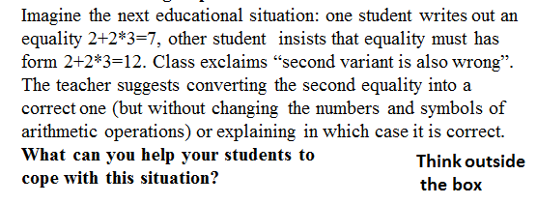
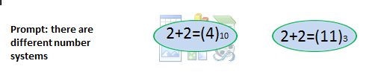

Task 3.
