HOMEWORK 3

Task 1. Fill in the gaps in the text. Make the abstract.
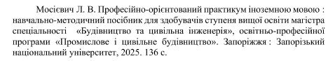
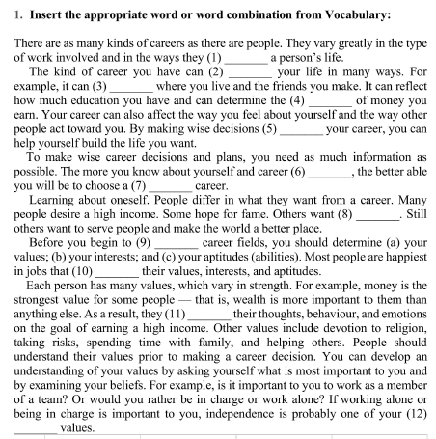

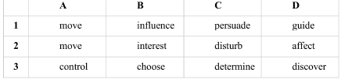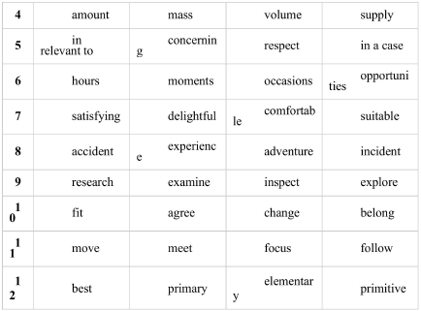
Task 2. Read the article at the link
https://fmo-journal.org/index.php/fmo/article/view/411/263
Write a summary.

Task 3. Read the article Academic writing at the link https://www.eapfoundation.com/writing/what/
Choose the text from Moodle (Методологія перекладу з іноземної мови науково-технічної літератури та літератури зі спеціальності, завдання 2 частина 1) and analyze it according article Academic writing.
Формальна та неформальна лексика

Informal | Formal | Informal | Formal
Ask | Enquire | Deal with | Handle
Ask for | Request | Tell | Inform
Book | Reserve | Wait for | Await
Check | Verify | Fight | Combat
Get | Receive | Use | Consume
Help | Assist | Go | Depart
Need | Request | Say sorry | Apologise
Start | Commence | End | Terminate
Tough | Difficult | Explain | Disclose
Set out | Display | Throw out | Eject
Old | Elderly | Say | Express
Afraid | Fearful | In the end | Finally
But | However | Wrong | Fncorrect
Go up | Increase | At first | Initially
Mad | Insane | Lucky | Fortunate
Smart | Intelligent | Small | Diminutive

