HOMEWORK 4

Task 1. Write answers on the following questions.
- What are your three most important conclusions from the following picture?

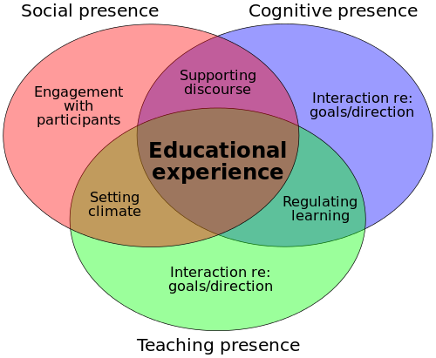
- How do you view your own role as teacher in high school? What is important to you? What kind of teacher do you want to be?

- How do YOU motivate your students?

- What are your three most important conclusions from the following information?
Some facts about memory
- Students capture only 20-40 percent of a lecture's main ideas in their notes.
- After three weeks, most students recall less than 10 percent of what was said in the lecture.
- A lecturer says 100-200 words a minute, and a student hears 50-100.
- In a typical lecture class, students are attentive just 40 percent of the time.

- Should a lecture be interactive? Explain why.

- What do you think are the educational methods associated with
K. Tsiolkovsky’s quote: “At first I made discoveries known to everyone, than – known to a few and finally unknown to anyone”? Explain your answer.

- Can you explain following “ladder”?
Create
Generate hypotheses, plan and execute something new, actualize
Evaluate
Evaluate, critically review using appropriate criteria
Analyse
Identify and extract central issues/relevant information, structure, separate fact from assumption, derive
Apply
Methodological approach, apply method to new challenges/problems
Understand
Interpret, translate, exemplify, classify, draw conclusions, compare, explain
Remember
Describe, define, name, list, pull out of long-term memory

- For each level of the “ladder” write 2 questions (according to your specialty) using verbs corresponding ton that level.
