ІНДИВІДУАЛЬНЕ ЗАВДАННЯ
Task 1. Provide comments on the figure according to the definition.
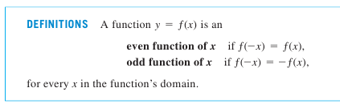

Task 2. Complete the task.
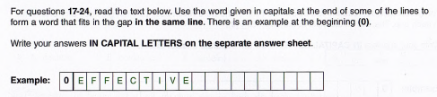
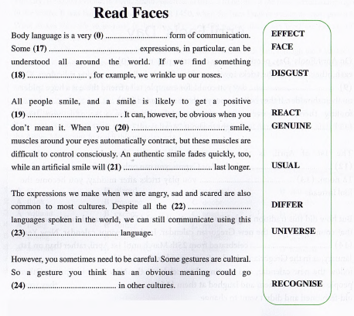
Task 3. Write an email to a potential employer.
Requirements:
- include a brief and clear subject line;
- begin with an appropriate greeting;
- introduce yourself and the purpose of your email. (Include your educational background);
- add at least 2 sentences with details about you. This can include your work experience, your skills, and any awards or other recognition that you have;
- request an interview/meeting;
- add a sentence or two to express your appreciation and a respectful closing.

Task 4.

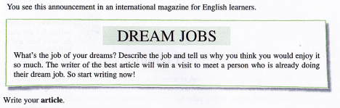

Task 5. Listen to the story at the link and write 2 sentences (advice) for your students
https://youtu.be/HdGsPrzQsxI?si=_oXCTJVHh4ENlSPg

