ДИВЕРСИФІКАЦІЯ СІЛЬСЬКОГО ТУРИЗМУ ЧЕРЕЗ ЗБАЛАНСОВАНІСТЬ ТА КРЕАТИВНІСТЬ: ПОШИРЕННЯ ЄВРОПЕЙСЬКОГО ДОСВІДУ В УКРАЇНІ

Поточний заліковий модуль 1 Європейські тенденції імплементування стратегій диверсифікації у сільському туризмі

Практичне заняття 2
ДИВЕРСИФІКАЦІЯ СІЛЬСЬКОГО ТУРИЗМУ В КРАЇНАХ ЄВРОПИ: БІЗНЕС-МОДЕЛІ ТА СТРАТЕГІЇ
Викладач:
к.е.н., доцент кафедри міжнародної економіки, природних ресурсів та економіки міжнародного туризму Венгерська Наталя Сергіївна

План
- Причини диверсифікації сільського туризму.
- Концепція нового сільського середовища як необхідної умови формування креативної сільської економіки.
- Бізнес-моделі в сфері сільського та креативного туризму.
- Стратегії диверсифікації у сільському туризмі.

Завдання 1. Дискусія, присвячена обговоренню причин диверсифікації сільської економіки та сільського туризму
- Підготовчий етап:
1.1 Викладач запрошує студентів сформулювати власне розуміння диверсифікації сільської економіки, навести приклади заходів, які сприяють диверсифікації.
1.2 Викладач запрошує студентів обговорити питання:
- Чому виникла необхідність диверсифікувати сільську економіку?
- Які причини диверсифікації сільського туризму?
- Чому збалансованість стала ключовим питанням туризму?

Завдання 2. Ознайомлення з креативністю та інноваціями у розвитку сільських територій ЄС.
- Перегляньте джерело щодо креативності URL : https://enrd.ec.europa.eu/sites/enrd/files/enrd-static/fms/pdf/B99849C0-00E8-A7DC-1D6A-775E2ED9F89A.pdf

- Прочитайте цитати відомих представників ЄС та з’ясуйте в чому полягає важливість креативності та інновацій як факторів сільського розвитку.

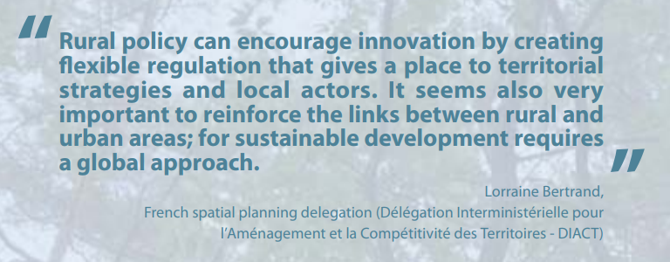

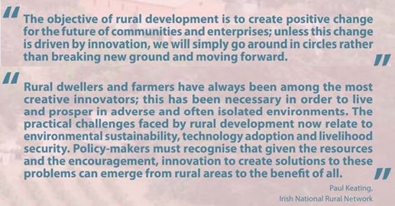

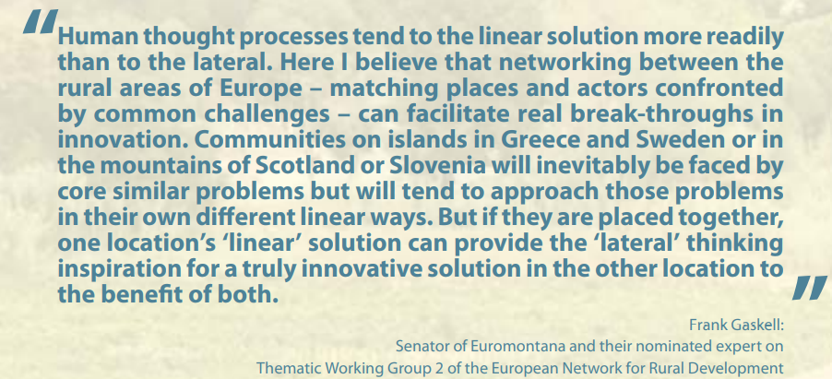

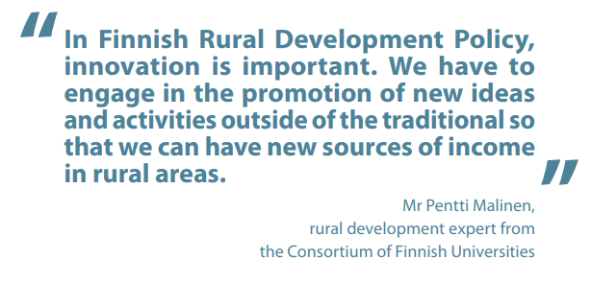
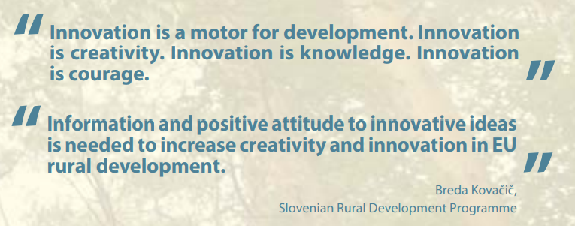
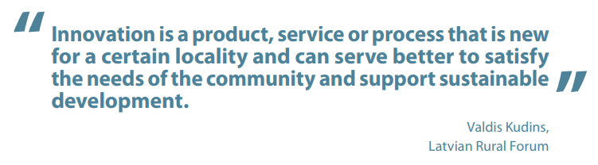
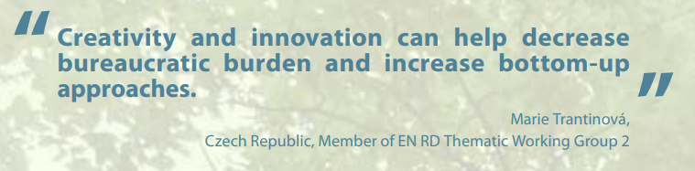

Завдання 3. Бліц-опитування
Викладач пропонує студентам пройти коротке опитування:
Що таке культурний туризм?
В чому полягає сутність та характерні ознаки креативного туризму?
Як Ви можете описати портрет туриста культурного туризму та туриста креативного?

Завдання 4. Мозковий штурм.
- Викладач формулює тему «мозкового штурму» - «Як в сільській місцевості перейти в моделі культурного туризму до креативного туризму» і запрошує студентів до обміну думками з таких приводів:
Чи можливо імплементувати досвід європейський територій в Україні щодо переходу від культурного туризму до креативного?
Які необхідно здійснити заходи у ланцюгу: «суб’єкти сільського туризму-громадськість-влада»?
Якби Ви були креативним туристом, то які б локації Вас цікавили?
Якби Ви були підприємцем креативного сільського туризму, то які б локації Ви запропонували своїм відвідувачам?

Завдання 5. Робота в групах.
- Студенти поділяються на дві групи та знайомляться з бізнес-моделлю сільського туризму (дидактичні матеріали до завдання 5).
- Кожна група аналізує дев’ять блоків бізнес-моделей.
- Отримавши результати, викладач запрошує студентів до обговорення питання: які ключові особливості формування ціннісної пропозиції у бізнес-моделі.

Завдання 6. Ділова гра «Бізнес в сфері креативного сільського туризму»
- Викладач пропонує студентам уявити себе командою бізнесменів ї креативного сільського бізнесу з двадцять першого століття, яка бажає впровадити сучасні бізнес-модулі креативного або сільського туризму. Студенти поділяються на дві групи та заповнюють шаблон бізнес-моделі Canvas (дидактичні матеріали до завдання 6).
- Студенти презентують бізнес-моделі Canvas креативного або сільського туризму.

Завдання 7. Бліц-опитування
Викладач пропонує студентам пройти коротке опитування:
В чому полягає сутність стратегії диверсифікації у туризмі?
Яка роль відіграє стратегія диверсифікації у туризмі для сталого розвитку території?
Як Ви можете охарактеризувати стратегії диверсифікації туризму на товарному / ринковому, регіональному та галузевому рівнях?

ІІІ. Дидактичні матеріали до завдань модуля 1
Дидактичні матеріали до завдання 5
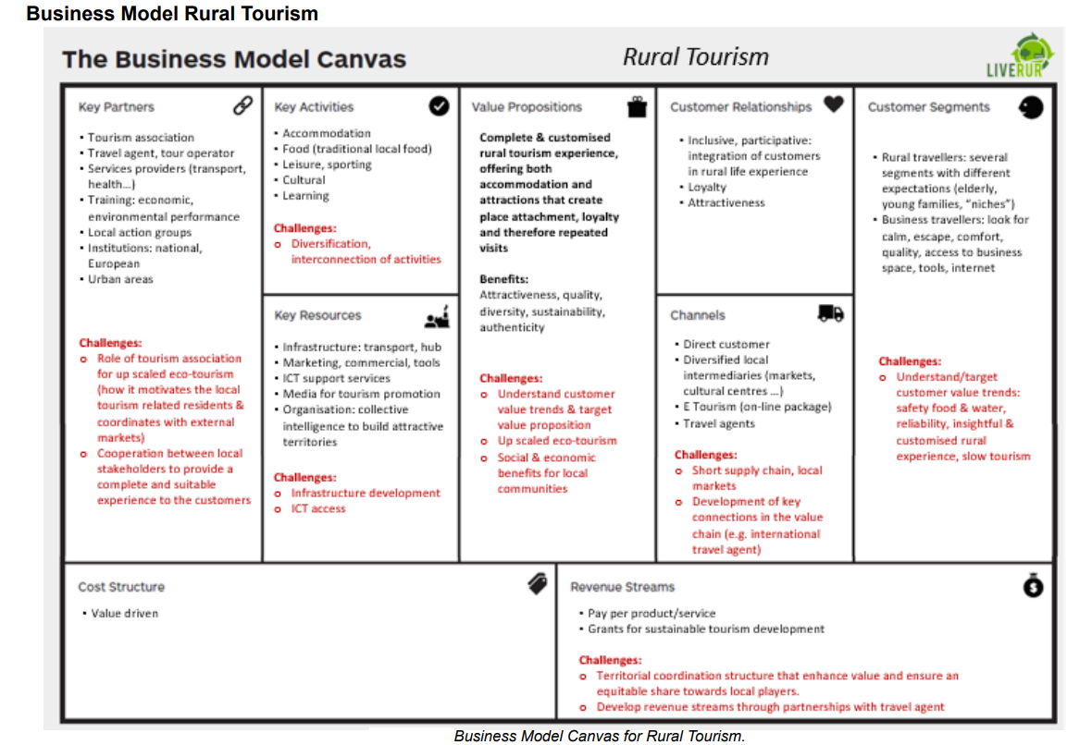
Дидактичні матеріали до завдання 6
 |  | Designed for: |  |  |  |  | Designed by: |  | Date: |  | Version:
Business Model Canvas
Key Partners | Key Activities |  | Value Propositions |  |  | Customer Relationships |  |  | Customer Segments
Who are our Key Partners? Who are our key suppliers? Which Key Resources are we acquiring from partners? Which Key Activities do partners perform?  MOTIVATIONS FOR PARTNERSHIPS: Optimization and economy, Reduction of risk and uncertainty, Acquisition of particular resources and activities | What Key Activities do our Value Propositions require? Our Distribution Channels? Customer Relationships? Revenue streams?  CATEGORIES:  Production, Problem Solving, Platform/Network |  | What value do we deliver to the customer? Which one of our customer’s problems are we helping to solve? What bundles of products and services are we offering to each Customer Segment? Which customer needs are we satisfying?  CHARACTERISTICS: Newness, Performance, Customization, “Getting the Job Done”, Design, Brand/Status, Price, Cost Reduction, Risk Reduction, Accessibility, Convenience/Usability |  |  |  | What type of relationship does each of our Customer Segments expect us to establish and maintain with them? Which ones have we established? How are they integrated with the rest of our business model? How costly are they? |  | For whom are we creating value? Who are our most important customers? Is our customer base a Mass Market, Niche Market, Segmented, Diversified, Multi-sided Platform
 | Key Resources |  |  |  |  |  | Channels
 | What Key Resources do our Value Propositions require? Our Distribution Channels? Customer Relationships Revenue Streams?  TYPES OF RESOURCES: Physical, Intellectual (brand patents, copyrights, data), Human, Financial |  |  |  |  |  | Through which Channels do our Customer Segments want to be reached? How are we reaching them now? How are our Channels integrated? Which ones work best? Which ones are most cost-efficient? How are we integrating them with customer routines?
Cost Structure |  |  |  | Revenue Streams
What are the most important costs inherent in our business model? Which Key Resources are most expensive? Which Key Activities are most expensive?  IS YOUR BUSINESS MORE: Cost Driven (leanest cost structure, low price value proposition, maximum automation, extensive outsourcing), Value Driven (focused on value creation, premium value proposition).  SAMPLE CHARACTERISTICS: Fixed Costs (salaries, rents, utilities), Variable costs, Economies of scale, Economies of scope |  |  |  | For what value are our customers really willing to pay? For what do they currently pay? How are they currently paying? How would they prefer to pay? How much does each Revenue Stream contribute to overall revenues?  TYPES: Asset sale, Usage fee, Subscription Fees, Lending/Renting/Leasing, Licensing, Brokerage fees, Advertising  FIXED PRICING: List Price, Product feature dependent, Customer segment dependent, Volume dependent  DYNAMIC PRICING: Negotiation (bargaining), Yield Management, Real-time-Market

 |  | Designed for: |  |  |  |  | Designed by: |  | Date: |  | Version:
Business Model Canvas
Key Partners | Key Activities |  | Value Propositions |  |  | Customer Relationships |  |  | Customer Segments
 | Key Resources |  |  |  |  |  | Channels
Cost Structure |  |  |  | Revenue Streams

