Зареєструйтесь на https://expo.dev/snacks

Структура проєкту має виглядати як на рисунку 1

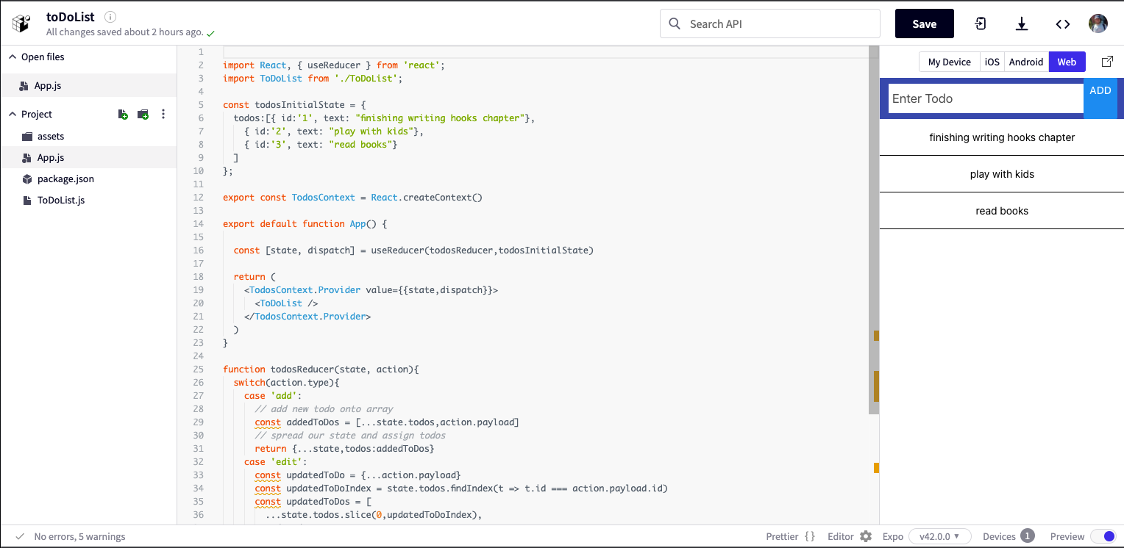

Створіть файл «package.json»

{
"dependencies": {
"prop-types": "^15.5.0",
"native-base": "^2.13.0",
"uuid-random": "^1.3.2",
"expo-status-bar": "~1.0.4",
"react-native-vector-icons": "^7.0.0",
"react-native-swipe-list-view": "^3.2.7"
}
}

Створіть файл і назвіть його «ToDoList.js»

import React, { useContext, useState } from 'react'
import { TodosContext } from './App'
import { SwipeListView } from 'react-native-swipe-list-view';
import { Header, Item, Input } from 'native-base';
import { StyleSheet, TouchableOpacity, View, Text, Button } from 'react-native';
import uuid from 'uuid-random';

export default function ToDoList() {
// receive state and dispatch from App.js
const {state, dispatch} = useContext(TodosContext);
const [todoText, setTodoText] = useState("")
const [editMode, setEditMode] = useState(false)
const [editTodo, setEditTodo] = useState(null)
const buttonTitle = editMode ? "Edit" : "Add";

const handleSubmit = () =>{
if(editMode){
dispatch({type: 'edit', payload:{...editTodo,text:todoText}})
setEditMode(false)
setEditTodo(null)
}
else{
const newToDo = {id: uuid(), text: todoText};
dispatch({type: 'add', payload: newToDo})
}
setTodoText('') // to clear field after adding
}

const renderItem = data => (
<View style={styles.rowFront}>
<Text>{data.item.text}</Text>
</View>
);

const renderHiddenItem = (data, rowMap) => (
<View style={styles.rowBack}>
<TouchableOpacity onPress={() => editRow(data.item, rowMap)}>
<Text>Edit</Text>
</TouchableOpacity>
<TouchableOpacity
style={[styles.backRightBtn]}
onPress={() => deleteRow(data.item)}
>
<Text style={{color: '#FFF'}}>Delete</Text>
</TouchableOpacity>
</View>
);

const deleteRow = (todo) => {
dispatch({type:'delete',payload:todo});
};

const editRow = (todo,rowMap) => {
setTodoText(todo.text)
setEditMode(true)
setEditTodo(todo)
if (rowMap[todo.id]) {
rowMap[todo.id].closeRow();
}
};

return (
<View>
<Header searchBar>
<Item>
<Input
placeholder="Enter Todo"
onChangeText={text => setTodoText(text)}
value={todoText}
/>
</Item>
<Button transparent onPress={handleSubmit} title={buttonTitle} />

</Header>

<SwipeListView
data={state.todos}
renderItem={renderItem}
renderHiddenItem={renderHiddenItem}
leftOpenValue={75}
rightOpenValue={-75}
/>
</View>
);
}

const styles = StyleSheet.create({
rowFront: {
alignItems: 'center',
backgroundColor: '#FFF',
borderBottomWidth: 0.25,
justifyContent: 'center',
height: 50,
},
rowBack: {
alignItems: 'center',
backgroundColor: '#DDD',
flex: 1,
flexDirection: 'row',
justifyContent: 'space-between',
paddingLeft: 15,
},
backRightBtn: {
alignItems: 'center',
bottom: 0,
justifyContent: 'center',
position: 'absolute',
top: 0,
width: 75,
backgroundColor: 'red',
right: 0
}
});

Створіть файл і назвіть його «App.js»

import React, { useReducer } from 'react';
import ToDoList from './ToDoList';

const todosInitialState = {
todos:[{ id:'1', text: "finishing writing hooks chapter"},
{ id:'2', text: "play with kids"},
{ id:'3', text: "read books"}
]
};

export const TodosContext = React.createContext()

export default function App() {

const [state, dispatch] = useReducer(todosReducer,todosInitialState)

return (
<TodosContext.Provider value={{state,dispatch}}>
<ToDoList />
</TodosContext.Provider>
)
}

function todosReducer(state, action){
switch(action.type){
case 'add':
// add new todo onto array
const addedToDos = [...state.todos,action.payload]
// spread our state and assign todos
return {...state,todos:addedToDos}
case 'edit':
const updatedToDo = {...action.payload}
const updatedToDoIndex = state.todos.findIndex(t => t.id === action.payload.id)
const updatedToDos = [
...state.todos.slice(0,updatedToDoIndex),
updatedToDo,
...state.todos.slice(updatedToDoIndex + 1)
];
return {...state, todos: updatedToDos}
case 'delete':
const filteredTodoState = state.todos.filter( todo => todo.id !== action.payload.id)
return {...state, todos: filteredTodoState}
default:
return todosInitialState
}
}

Завантажте виконаний проєкт у moodle.

